Acceptability of an AI-Based Student Performance Evaluation
and Monitoring System In Non-Medical Programs

A Capstone Project Presented to the

Faculty of the

College of Information Technology and Engineering

Southwestern University - PHINMA

In Partial Fulfillment

of the Requirements for the Degree

BACHELOR OF SCIENCE IN INFORMATION TECHNOLOGY

By

DIAN XANE A. CUADRA
TEOKAN DURAN D. DEMIRCAN
EDWIN KYLE S. FLORENDO
MYCO ANGEL LOU A. VILLOMO

2026
TABLE OF CONTENTS

PAGE
TITLE PAGE . . . . . . . . . . . . . . . . . . . . . . . . . . . . . . . . . . . . . . . . . . . . . . . . . . . . . . . . . . . . . . . . . . |  | 1
TABLE OF CONTENTS . . . . . . . . . . . . . . . . . . . . . . . . . . . . . . . . . . . . . . . . . . . . . . . . . . . . . . . . |  | 2
LIST OF FIGURES . . . . . . . . . . . . . . . . . . . . . . . . . . . . . . . . . . . . . . . . . . . . . . . . . . . . . . . . . . . . . |  | 4
LIST OF TABLES . . . . . . . . . . . . . . . . . . . . . . . . . . . . . . . . . . . . . . . . . . . . . . . . . . . . . . . . . . . . . . |  | 6
CHAPTER
1 | INTRODUCTION
 | Background of the Study . . . . . . . . . . . . . . . . . . . . . . . . . . . . . . . . . . . .  Statement of the Problem . . . . . . . . . . . . . . . . . . . . . . . . . . . . . . . . . . .  Objectives of the Study . . . . . . . . . . . . . . . . . . . . . . . . . . . . . . . . . . . . . .  Scope and Limitations . . . . . . . . . . . . . . . . . . . . . . . . . . . . . . . . . . . . . .  Significance of the Study . . . . . . . . . . . . . . . . . . . . . . . . . . . . . . . . . . . | 8  10  10  11  17
 | Definition of Terms . . . . . . . . . . . . . . . . . . . . . . . . . . . . . . . . . . . . . . . . . | 20
2 | REVIEW OF RELATED LITERATURE  Review of Related Literatures Introduction. . . . . . . . . . . . . . . . . .  Challenges in Student Performance Monitoring and Academic Data Management . . . . . . . . . . . . . . . . . . . . . . . . . . . . . . . . . . . . . . . . . .  Design Principles and AI-Integrated Features in Academic Monitoring Systems . . . . . . . . . . . . . . . . . . . . . . . . . . . . . . . . . . . . . .. . .  Effectiveness of AI-Integrated Systems in Enhancing Academic Decision-Making and Data Security . . . . . . . . . . . . . . . . . . . . . . . . .  Summary of the RRLs . . . . . . . . . . . . . . . . . . . . . . . . . . . . . . . . . . . . . . | 23  24  25  26  27
3 | METHODOLOGY  Systems Architecture and Methodology Description . . . . . . . . .  Research Framework and Design . . . . . . . . . . . . . . . . . . . . . . . . . . .  Sampling and Techniques . . . . . . . . . . . . . . . . . . . . . . . . . . . . . . . . . . .  Data Gathering Tools, Techniques, and Timeline. . . . . . . . . . . . .  Software Development Methodology . . . . . . . . . . . . . . . . . . . . . . . .  Data Analysis Tools and Techniques . . . . . . . . . . . . . . . . . . . . . . . . . | 29  29  31  35  44  50
4 | RESULTS AND DISCUSSION  Response Rate . . . . . . . . . . . . . . . . . . . . . . . . . . . . . . . . . . . . . . . . . . . . . .  Demographics . . . . . . . . . . . . . . . . . . . . . . . . . . . . . . . . . . . . . . . . . . . . . .  Processes Involved in Student Performance Evaluation and  Monitoring Among SWUNEXT Faculty and Academic  Administrators. . . . . . . . . . . . . . . . . . . . . . . . . . . . . . . . . . . . . . . . . . . . . .  Challenges in Student Performance Evaluation and Monitoring  Among SWUNEXT Faculty and Academic Administrators. . . . .  Conceptual Framework . . . . . . . . . . . . . . . . . . . . . . . . . . . . . . . . . . . . .  Wireframes . . . . . . . . . . . . . . . . . . . . . . . . . . . . . . . . . . . . . . . . . . . . . . . . .  Mockups. . . . . . . . . . . . . . . . . . . . . . . . . . . . . . . . . . . . . . . . . . . . . . . . . . . . . | 54  56  58  65  70  77  79
 | REFERENCES | 91

LIST OF FIGURES

Figure No. | Figure Title | Page
1 | Sample Size Calculation | 34
2 | Agile Methodology | 45
3 | Kanban Framework | 46
4 | Percentage Formula | 51
5 | Weighted Mean Formula | 51
6 | Standard Deviation Formula | 52
7 | Maximum Sample Standard Deviation Formula | 53
8 | PowerBI | 53
9 | Distribution of Faculty Respondents by College / Department | 56
10 | Distribution of Academic Administrator Respondents by College / Department | 57
11 | Distribution of Academic Administrator Respondents by Position | 57
12 | Current Student Performance Evaluation and Monitoring  Process Flow for Academic Administrators within SWUNEXT | 58
13 | Conceptual Framework of the System Using the Input-Process-Output Model | 71
14 | Context Flow Diagram | 71
15 | Use Case Diagram | 74
16 | Data Flow Diagram | 76

LIST OF TABLES

Table No. | Table Title | Page
1 | Population Size of Respondents | 33
2 | Sample Size of Respondents | 35
3 | Capstone Manuscript Timeline | 40
4 | Estimated Project Costs | 43
5 | Software Development Tools and Platforms | 48
6 | Response Rate According to Respondent Roles | 55
7 | Response Rate According to College / Department | 55
8 | Frequency of Each Procedure in Student Performance Evaluation and Monitoring for Academic Administrators within SWUNEXT | 59
9 | Current Student Performance Evaluation and Monitoring Process Flow for Faculty Members within SWUNEXT | 63
10 | Frequency of Each Procedure in the Student Performance Evaluation and Monitoring Process for Faculty Members within SWUNEXT | 65
11 | Challenges in Student Performance Evaluation and Monitoring  Among Academic Administrators within SWUNEXT | 67
12 | Challenges in Student Performance Evaluation and  Monitoring Among Faculty Members within SWUNEXT | 68

CHAPTER 1

INTRODUCTION
In recent years, Higher Education Institutions (HEIs) have increasingly adopted digital technologies to manage student records and monitor academic performance. However, many departments still rely on fragmented systems or partially manual processes for computing grades, recording attendance, and evaluating student progress. These practices often result in delays in data processing, inconsistencies in records, and increased workload for faculty members.
Effective academic decision-making depends on timely and organized access to student performance data. When records are stored across multiple platforms or handled manually, it becomes difficult for faculty to efficiently analyze student progress and identify those who may need academic support. As a result, interventions are often delayed, reducing the opportunity to assist students at an earlier stage.
Within SWUNEXT, a cluster of colleges and schools offering non-health allied programs at Southwestern University–PHINMA, faculty members face similar challenges in monitoring and evaluating student performance. The lack of an integrated system makes it difficult to consolidate academic data and generate meaningful insights that can support instructional decisions.
To address these challenges, this study proposes the development and assessment of an AI-Based Student Performance Evaluation and Monitoring System designed to support faculty academic decision-making in SWUNEXT. The system integrates artificial intelligence techniques to analyze academic indicators such as examination results, assignments, attendance, and participation. Through data analysis, the system can help faculty identify performance trends and students who may be at risk.
This study aims to determine the acceptability of the proposed AI-Based system to improve student performance monitoring and support data-informed academic decisions among faculty members in SWUNEXT. By providing a centralized and analytical platform, the system seeks to offer a practical solution to current challenges in academic monitoring.

Background of the Study
Academic administrators and teaching faculty members play an important role in monitoring and evaluating student learning to maintain educational quality. Student performance assessment typically involves analyzing academic indicators such as examination results, assignments, attendance, and participation. These indicators help faculty members determine grades, identify learning gaps, and provide appropriate academic support. However, as student populations increase and academic requirements become more complex, managing and interpreting performance data becomes more challenging for educators.
Despite the availability of digital tools, many institutions still rely on fragmented or partially manual systems in handling academic records. In many cases, grades are stored in spreadsheets, attendance is recorded separately, and participation is tracked through different platforms or manual processes. This lack of integration often leads to delays in analyzing student performance, inconsistencies in evaluation, and difficulty in identifying students who may need immediate academic intervention. As a result, faculty members spend more time managing data rather than using it to support decision-making.
Within SWUNEXT, a cluster of non-health allied programs in Southwestern University–PHINMA, similar challenges are experienced by faculty members in assessing and monitoring student performance. The absence of a centralized and integrated system makes it difficult to consolidate academic data and generate meaningful insights. This limits the ability of faculty to make timely and informed academic decisions.
Recent advancements in educational technology have introduced artificial intelligence as a tool that can enhance academic monitoring processes. Artificial intelligence techniques, such as machine learning, can analyze large volumes of academic data and identify patterns related to student performance. When integrated into academic systems, these capabilities can assist faculty in identifying trends and students who may require early intervention. However, there is still a need to explore how these technologies can be effectively applied within specific institutional contexts such as SWUNEXT.
In response to these challenges, this study proposes the development and evaluation of an AI-Based Student Performance Evaluation and Monitoring System designed to support faculty academic decision-making in SWUNEXT. The proposed system integrates performance analytics, predictive insights, customizable evaluation criteria, and automated feedback features to assist educators in monitoring student progress. By providing a centralized and intelligent platform, the system aims to improve how faculty assess student performance and make data-informed decisions.

Statement of the Problem
This study seeks to assess the acceptability of an AI-Based Student Performance Monitoring System in enhancing academic decision-making among SWUNEXT faculty. Specifically, this study seeks to answer the following research questions:
- What are the existing processes involved in each department of SWUNEXT when assessing and monitoring student performance?
- What are the challenges encountered by the faculty of each department of SWUNEXT when assessing students and monitoring their performance?
- What system features and design frameworks can be used and integrated to develop an AI Based Student Performance Monitoring System to address the identified challenges in assessing students and monitoring their performance?
- What is the level of acceptability of the proposed AI based student performance evaluation and monitoring system in terms of:
- Efficiency
- Accuracy
- Relevance of Information Retrieval
- Data Security

Objectives of the Study
This study aims to develop and evaluate an AI-Based Student Performance Monitoring System that improves the accuracy, efficiency, and security of student performance monitoring at SWUNEXT. The system is designed to support educators in making data-informed decisions while ensuring the protection of sensitive student information through integrated analytical tools and security mechanisms. Specifically, this study aims to:
- Identify and present a flowchart of the existing processes involved in each department of SWUNEXT when assessing and monitoring student performance.
- Identify the challenges encountered by the faculty of SWUNEXT when assessing students and monitoring their performance.
- Design and develop an AI based Student Performance Monitoring System to address the identified challenges in Research Question 2.
- Determine the level of acceptability of the proposed system in terms of:
- Efficiency
- Accuracy
- Relevance of Information Retrieval
- Data Security

Scope and Limitations
This study focuses on the design, development, and evaluation of an AI-Based Student Performance Evaluation and Monitoring System intended for use in the different departments of the SWUNEXT cluster of colleges and schools at Southwestern University PHINMA, namely, the Business School (B-School), the College of Engineering (CoE), the College of Information Technology (CIT), and the School of Design and Communication (SD+C). The research aims to improve student performance monitoring by integrating analytical capabilities that assist educators in interpreting academic data while strengthening security measures for managing student records. The system is designed to support educators in analyzing student performance information and generating insights that contribute to more informed academic decision-making.
The scope of the study covers the major stages of the software development lifecycle, including requirements analysis, system architecture design, system development, testing, and user evaluation. The proposed system processes academic indicators such as examination scores, assignments, attendance records, and participation data to generate performance assessments and analytical insights.
The respondents of the study include faculty members and academic administrators (e.g., deans and program heads) within the different colleges and schools affiliated with the SWUNEXT cluster. Participants will be selected using stratified random sampling, grouping them based on their roles to ensure proper representation. However, the study is limited to selected participants within SWUNEXT, and the findings may not fully represent other academic clusters or institutions due to differences in policies, practices, and technological resources. The acceptability of the system depends on the accuracy and completeness of the data used during testing. The system is not intended to replace institutional grading policies or fully automate academic decisions; rather, it serves as a decision-support tool for faculty members and academic administrators within the SWUNEXT cluster.
The analytical insights generated by the system depend on the accuracy and completeness of the academic data used during testing. The system is not intended to replace institutional grading policies or fully automate academic decision-making; instead, it functions as a decision-support tool that assists educators in interpreting student performance data. Furthermore, integration with external Learning Management Systems or institutional databases may be limited to simulated or controlled environments depending on system compatibility and access constraints.
Scope of the Study
- Respondents: The participants of this study include the teaching faculty members and academic administrators of colleges and schools affiliated with the SWUNEXT cluster, who are willing to participate in the evaluation of the proposed system. Respondents will be chosen using stratified random sampling according to their roles (e.g. teaching faculty member / academic administrator).
- Locale: The study will be conducted within the colleges and schools affiliated with the SWUNEXT cluster of colleges and schools at Southwestern University PHINMA, namely the Business School (B-School), the College of Engineering (CoE), the College of Information Technology (CIT), and the School of Design and Communication (SD+C).
- Variables: The study measures the level of acceptability of the proposed system based on the following indicators:
  - Efficiency - the system’s ability to simplify and increase the speed of student performance monitoring tasks;
  - Accuracy - the correctness and reliability of the student performance data stored within the proposed system;
  - Relevance of Information Retrieval - the usefulness and clarity of the insights provided by the system in relation to student performance monitoring; and
  - Data Security - the protection of sensitive personal and academic data within the system.
- Methodology: The study follows a developmental research approach, involving the design, development, and evaluation of the proposed system. Data will be collected through surveys, secondary research, and system testing to assess the effectiveness of the AI-based system in improving performance monitoring and ensuring the secure management of academic information.
Scope of the System
The proposed system is designed to support faculty members in evaluating and monitoring student academic performance within SWUNEXT. It integrates analytical tools and AI-assisted capabilities to improve student performance monitoring and support academic decision-making. The system includes the following core functionalities:
- Performance Data Management: Modules that enable the encoding, storage, and organization of academic records such as examination scores, assignments, attendance, and participation. This allows centralized and structured management of student performance data.
- AI-Integrated Performance Analysis: The system incorporates artificial intelligence techniques to analyze academic indicators, generate performance insights, and identify trends in student achievement. These capabilities assist educators in monitoring progress and identifying students who may require academic intervention.
- Customizable Evaluation Criteria: Features that allow faculty members to define grading weight distributions for different academic components. This ensures flexibility in applying course-specific evaluation standards.
- Real-Time Analytics Dashboard: An interactive dashboard that presents performance summaries, trend visualizations, and analytical indicators. These insights help educators interpret student data and support more informed academic decisions.
- Security Mechanisms: The system integrates encryption and Role-Based Access Control (RBAC) to regulate user access and protect academic records. These mechanisms ensure the confidentiality and integrity of student information.
- Automated Feedback Generation: A feedback module that provides students with system-generated insights regarding their academic performance. This feature allows students to better understand their progress and encourages timely academic improvement.
Entire Limitation of the Study
This study is limited to the design, development, and evaluation of the proposed AI-Based Student Performance Evaluation and Monitoring System within a selected group of faculty members and academic administrators of colleges and schools affiliated with the SWUNEXT cluster. The findings of this research do not represent all academic institutions, as differences in institutional policies, technological infrastructure, and student populations may affect the applicability of the results.
The system is intended only as a decision-support tool and does not replace institutional grading policies or the professional judgment of faculty members. The insights generated by the system depend on the accuracy, completeness, and quality of the academic data used during testing.
The proposed system does not replace institutional grading policies or the professional judgment of educators. It functions solely as a decision-support and performance monitoring tool that assists in analyzing student performance data. Furthermore, the predictive insights generated by the system depend on the accuracy, completeness, and quality of the academic data used during system testing.
Limitation of the Study
- Generalizability: The findings of this study are limited to respondents within SWUNEXT, a cluster of non-health allied colleges and schools at Southwestern University–PHINMA. Differences in academic policies, grading systems, and technological resources may limit the applicability of the results to other academic clusters or educational institutions.
- Timeframe: The study is conducted within a limited academic period, which restricts the ability to evaluate the long-term impact of the system on performance monitoring and academic decision-making. Long-term sustainability, system updates, and extended user adaptation are beyond the scope of this research.
- User Proficiency: The evaluation of the proposed system depends on the digital literacy and adaptability of participating faculty members and students. Differences in technical skills, familiarity with digital platforms, or resistance to adopting new technology may influence the assessment of the system’s effectiveness.
Limitation of the System
- Hardware Dependency: The proposed system relies on the existing devices and network infrastructure available within SWUNEXT. The project does not include the provision or installation of additional hardware such as dedicated servers, computers, or networking equipment.
- Maintenance: The scope of the system covers its design, development, and initial deployment. Long-term technical maintenance, continuous software updates, and extended IT support beyond the initial implementation and user orientation are not included in the scope of this project.
- External Integration: The system functions primarily as an internal academic performance monitoring tool. Although integration with Learning Management Systems may be explored in the future, full interoperability with multiple external platforms or third-party educational systems is beyond the scope of the current implementation.
- Online Functionality: System accessibility may depend on the availability and stability of the institution’s local network or internet connection. Advanced cloud-based deployment, extended remote access capabilities, or large-scale distributed system implementation are not included in the present scope.
- Decision Authority: The system is designed to assist educators in monitoring student performance and generating analytical insights. It does not replace institutional grading policies or the professional judgment of educators, and it does not automatically determine final grades or academic decisions.

Significance of the Study
This study focuses on the acceptability of an AI-Based Student Performance Evaluation and Monitoring System designed to support academic decision-making within SWUNEXT, a cluster of non-health allied colleges and schools at Southwestern University–PHINMA. The findings of this research are expected to benefit the following stakeholders:
SWUNEXT Academic Units: The study may provide insights into how an AI-based system can be accepted and utilized within SWUNEXT. The findings can support the adoption of a more structured and data-driven approach to monitoring student performance and improving academic processes.
Faculty Members within the SWUNEXT Cluster: Faculty members, as the primary users of the system, may benefit from improved access to organized student data and analytical insights. The study can help determine whether the system is acceptable and useful in supporting their performance monitoring and academic decision-making tasks.
Academic Administrators within the SWUNEXT Cluster: Academic administrators may use aggregated performance analytics and trend reports to support institutional planning, curriculum evaluation, and academic policy review. The availability of structured academic data can assist administrators in identifying patterns in student performance and developing strategies to enhance institutional academic outcomes.
Students within the SWUNEXT Cluster: Students within may benefit from clearer monitoring of their academic performance and access to timely feedback generated by the system. Analytical insights and performance indicators may help students better understand their academic standing and identify areas that require improvement. Additionally, the system’s security mechanisms help ensure that student academic records are properly protected from unauthorized access or modification.
Future Researchers and the Academe: This study contributes to the growing body of research related to the integration of artificial intelligence in educational systems and secure academic data management. The findings of this research may serve as a reference for future studies exploring predictive analytics, educational technology, and the integration of information security practices within academic environments.
Researchers: The conduct of this study is significant to the researchers involved in terms of providing valuable experience in the design, development, implementation, and evaluation of learning analytics systems that conform to certain criteria of effectiveness, enhancing their expertise in system development and information security. The challenges, failures, successes, and lessons learned throughout the research process will enrich the researchers’ understanding of the complexities in implementing Information Technology solutions for Higher Education Institutions, thus informing the researchers’ future academic and professional endeavors.

Definition of Terms
To help you understand the technical terms used in this study, below are the definition of terms for your understanding.

Academic  Decision-Making | The process by which educators and administrators analyze student performance data to make informed decisions regarding grading, intervention, promotion, and instructional strategies.
Academic Indicators | Measurable components used to evaluate student performance, such as examination scores, quizzes, assignments, attendance, and class participation.
Artificial Intelligence (AI) | A branch of computer science that enables machines or systems to perform tasks that typically require human intelligence, such as analyzing data, recognizing patterns, and making predictions.
AI-Based System | A software system that incorporates artificial intelligence components to assist in analyzing data and supporting decision-making processes.
Algorithm | A step-by-step set of rules or instructions followed by a computer to solve a problem or perform a task.
Analytics Dashboard | A visual interface that displays summarized data, charts, and performance indicators to help users easily interpret information.
Confidentiality | The principle that ensures information is accessible only to authorized individuals.
Data Integrity | The assurance that data remains accurate, consistent, and unaltered unless modified by authorized users.
Data Privacy | The protection of personal and sensitive information from unauthorized access, disclosure, or misuse.
Database | An organized collection of structured data that can be easily accessed, managed, and updated electronically.
Encryption | A security process that converts readable data into coded form to prevent unauthorized access.
Faculty | An instructor or educator responsible for teaching, evaluating, and monitoring student performance.
Information Security | The protection of information and data systems against unauthorized access, use, disclosure, disruption, modification, or destruction.
Machine Learning | A subset of artificial intelligence that allows systems to learn from data and improve their performance without being explicitly programmed for every task.
Predictive Analytics | The use of statistical techniques and machine learning algorithms to analyze historical data and forecast possible future outcomes.
Role-Based Access  Control (RBAC) | A security mechanism that restricts system access based on the user’s assigned role within the organization.
System Architecture | The overall structure and design of a system, including its components and how they interact with each other.
User Authentication | The process of verifying the identity of a user before granting access to a system.

CHAPTER 2

REVIEW OF RELATED LITERATURE
Academic institutions continuously generate large volumes of student data from assessments, attendance, coursework, and participation. These data provide valuable insights for evaluating student performance and identifying learning gaps; however, managing and analyzing such large volumes of data has become increasingly complex for many institutions.
To address these challenges, institutions have adopted data-driven approaches such as educational data mining and learning analytics. These technologies enable the extraction of meaningful patterns from academic data, allowing educators to better understand student performance and improve decision-making processes (Du et al., 2020). In addition, artificial intelligence (AI) has emerged as a powerful tool in education, particularly through machine learning techniques that analyze historical data and generate predictive insights (Namoun & Alshanqiti, 2021).
Despite these advancements, many academic institutions still experience inefficiencies in performance monitoring due to fragmented systems, limited analytical capabilities, and inadequate data security measures. These issues highlight the need for integrated systems that can support both academic decision-making and secure data management.
This chapter reviews related literature on the challenges in student performance monitoring, the design and integration of AI-based systems in education, and the effectiveness of these systems in enhancing academic decision-making and data security.

Challenges in Student Performance Monitoring and Academic Data Management
Monitoring student performance is essential for evaluating academic progress and providing timely interventions. However, many institutions still encounter significant challenges due to fragmented systems and manual processes.
Ifenthaler and Yau (2020) explain that learning analytics can improve student monitoring by enabling institutions to analyze educational data and identify learning patterns. However, their study also highlights that many institutions struggle with integrating analytics tools into existing systems, limiting their effectiveness. These findings suggest that while learning analytics tools improve data interpretation (Ifenthaler & Yau, 2020), their effectiveness is limited without centralized systems (Du et al., 2020). Furthermore, accurate prediction depends on data quality and integration, which remains a challenge in many institutions (Namoun & Alshanqiti, 2021).
Namoun and Alshanqiti (2021) further note that accurate prediction of student performance depends on well-organized and consistent datasets. Their findings indicate that institutions often face issues such as inconsistent data collection, fragmented records, and limited analytical tools. Supporting this, Nahar et al. (2021) found that although machine learning techniques can improve prediction accuracy, their effectiveness is constrained when data is incomplete or poorly structured.
These studies indicate that institutions commonly experience challenges such as delayed access to academic data, difficulty identifying at-risk students, fragmented records, and weak access control over sensitive information. Such limitations reduce the ability of educators to make timely and informed academic decisions.
This is further supported by Ab Rahman et al. (2024), who emphasized that the effectiveness of predictive systems is highly dependent on the availability of structured and high-quality academic data.

Design Principles and AI-Integrated Features in Academic Monitoring Systems
Artificial intelligence has become an essential component in improving academic monitoring systems by enabling automated analysis and predictive capabilities. Machine learning techniques, in particular, have been widely applied to analyze academic data and support performance evaluation.
Albreiki et al. (2021) found that machine learning models can effectively predict student performance by analyzing indicators such as grades, attendance, and engagement. Similarly, Nahar et al. (2021) demonstrate that data mining techniques can identify performance trends and improve the accuracy of academic predictions.
Beyond prediction, AI technologies also contribute to improving the overall design of educational systems. Yuskovych-Zhukovska et al. (2022) highlighted that AI can support intelligent systems and adaptive learning environments, allowing educators to adjust teaching strategies based on student needs. In addition, Merino-Campos (2025) explains that AI enables personalized learning by analyzing student behavior and providing tailored feedback, while Demartini et al. (2024) show that AI systems can dynamically adjust educational content based on student progress.
These studies collectively suggest that AI should not only be used for prediction but also integrated into system design to enhance usability and effectiveness. This suggests that AI systems should extend beyond predictive functions and operate as integrated decision-support tools within academic environments. Effective academic monitoring systems should incorporate key design principles such as centralized data management, predictive analytics, real-time dashboards, and customizable evaluation criteria. In addition, security features such as encryption and role-based access control are essential to ensure safe handling of academic data.
Building on these design principles, the effectiveness of AI-integrated systems can be evaluated in terms of their acceptability within the academic environment. These principles directly inform the design of the proposed system in this study, which integrates analytical capabilities, centralized data management, and security mechanisms into a unified platform.

Effectiveness of AI-Integrated Systems in Enhancing Academic Decision-Making and Data Security
The integration of artificial intelligence into academic systems has significantly improved the ability of institutions to support data-driven decision-making. By analyzing large datasets, AI-based systems can generate insights that help educators understand student performance patterns and respond more effectively.
Ab Rahman et al. (2024) found that machine learning models can accurately predict student performance and identify students at risk of academic failure. This allows educators to implement early interventions and improve learning outcomes. Similarly, Alshabandar et al. (2022) report that AI-based systems provide more accurate predictions compared to traditional statistical methods, enhancing the reliability of academic analysis.
In addition to improving decision-making, AI-integrated systems also enhance the organization and accessibility of academic data. Centralized systems allow institutions to store, manage, and retrieve student information more efficiently, enabling real-time monitoring and analysis of performance trends. These capabilities support faster and more informed academic decisions.
However, as academic systems become more data-driven, ensuring data security becomes increasingly important. The use of digital systems requires strong security mechanisms to protect sensitive student information from unauthorized access, modification, or loss. Implementing encryption and role-based access control helps maintain the confidentiality and integrity of academic records.
Overall, these findings demonstrate that AI-integrated systems significantly improve the efficiency of performance monitoring, enhance the identification of at-risk students, improve the organization and accessibility of academic records, and strengthen the protection of academic information.

Summary of the RRLs
The reviewed literature highlights the growing importance of artificial intelligence and data analytics in improving academic monitoring systems. Studies show that educational data mining and machine learning techniques can effectively analyze academic data, identify patterns, and predict student performance.
However, the literature also reveals persistent challenges in existing systems, including delayed access to academic data, fragmented records, and limited analytical capabilities. While many studies focus on predictive models, fewer address the integration of system features and data security within a single platform.
Moreover, existing research emphasizes the importance of combining analytical capabilities with effective system design and security measures. AI-integrated systems have been shown to improve academic decision-making by providing timely insights and enabling early identification of at-risk students. At the same time, secure data management practices are necessary to protect sensitive academic information.
While existing research highlights the importance of managing educational data, few studies simultaneously address both academic decision-making support and data security within a unified system framework. This gap highlights the need for a comprehensive and integrated system that combines performance evaluation, predictive analytics, and security mechanisms to improve academic monitoring processes.

CHAPTER 3

RESEARCH AND SYSTEM DEVELOPMENT METHODOLOGY
This chapter provides a detailed description of the research methodology utilized in achieving this study’s research objectives, as well as the system architecture of the proposed AI-Based Student Performance Evaluation and Monitoring System. This chapter covers the research framework and design, sampling techniques, data collection tools, techniques, and procedures, and data analysis and visualization techniques and tools used in this study, as well as the software development methodology and tools, project timeline, and use case diagram of the proposed system.

Research Framework and Design
This study employs a quantitative research approach in addressing both the conceptual and computational aspects of the student performance evaluation and monitoring processes of the colleges and schools affiliated with SWUNEXT.
For Research Question 1, the researchers opted to use a quantitative research approach with a descriptive research design. A quantitative research approach is suitable for a controlled quantifiable and statistical measurement of the processes involved in evaluating and monitoring student performance among the faculty members of the colleges and schools affiliated with SWUNEXT. Quantitative research focuses on the collection and analysis methods and techniques of numerical data, and is utilized in finding objective and systematic answers to research questions or hypotheses (Slater & Hasson, 2025). For Research Question 1, a descriptive research design is suited for identifying and characterizing the processes involved in monitoring student performance at SWUNEXT, which serves as the baseline for the development of an AI-Based Student Performance Monitoring System that enhances these processes. Descriptive research is a type of research design used to determine the characteristics of a population or phenomenon in order to obtain a factual and systematic description of its condition (Salisi & Balahadia, 2025).
For Research Question 2, the researchers opted to use a quantitative research approach with a descriptive research design. A quantitative research approach is suitable for a controlled quantifiable and statistical measurement of the challenges in the student performance evaluation and monitoring processes experienced by faculty members and academic administrators within SWUNEXT. Quantitative research focuses on the collection and analysis methods and techniques of numerical data, and is utilized in finding objective and systematic answers to research questions or hypotheses (Slater & Hasson, 2025). For Research Question 1, a descriptive research design is suited for identifying and characterizing the challenges in the student performance evaluation and monitoring processes experienced by faculty members and academic administrators within SWUNEXT, which serves as the primary motivation for the development of an AI-Based Student Performance Monitoring System. Descriptive research is a type of research design used to determine the characteristics of a population or phenomenon in order to obtain a factual and systematic description of its condition (Salisi & Balahadia, 2025).
For Research Question 3, the researchers opted to use a qualitative secondary research approach with a systematic literature review design. According to Manu and Akotia (2021), qualitative secondary research is a “a systematic approach to the use of existing data to provide ways of understanding that may be additional to or different from the data’s original purpose”. A secondary research approach is suited for understanding the latest advances in the literature relevant to the design principles, system features, and security controls necessary in the development of an AI-Based Student Performance Evaluation and Monitoring System that addresses the identified challenges in the existing student performance evaluation and monitoring process as experienced among faculty members and academic administrators within SWUNEXT.
For Research Question 4, the researchers opted to use a quantitative research approach with a developmental research design because a quantitative research approach is suited for the controlled statistical measurement of variables in the assessment of the acceptability of the proposed AI-Based Student Performance Evaluation and Monitoring System as a solution in improving the student performance evaluation and monitoring of the colleges and schools affiliated with SWUNEXT, while a developmental research design is suited for systematically guiding the development and assessment of the acceptability of the proposed AI-Based Student Performance Evaluation and Monitoring System in terms of the existing student performance evaluation and monitoring processes of academic institutions, and thereby, in addressing the challenges encountered by faculty members of the colleges and schools affiliated with SWUNEXT in evaluating and monitoring student performance. Developmental research focuses on the systematic design, development, and evaluation of products and solutions that meet criteria for internal consistency and effectiveness (Salisi & Balahadia, 2025).

Sampling and Techniques
The researchers opted to utilize a probability sampling method using a stratified random sampling technique without replacement in selecting the respondents of the study. According to Rahman (2023), probability sampling is commonly used when ensuring a method for equal probability of selection, conducting studies that are generalizable to a wide population. Stratified random sampling is a probability sampling technique that involves the classification of a population into distinct groups, also known as strata, and the random selection of participants from each stratum to form a representative sample of the entire population (Ahmed, 2024). Stratified random sampling ensures equal representation of strata, providing comparability within or across strata. (Ahmed, 2024).
The researchers formulated the following inclusion criteria for the various data collection procedures in order to ground the applicability of the respondent samples. For the pre-development and post development surveys, the respondents:
- Must be academic administrators, including but not limited to: Deans, Assistant Deans, Program Directors / Executive Directors, Program Chairs, and Program Heads, who are currently employed or contracted with a college or school affiliated with the SWUNEXT cluster of colleges and schools at Southwestern University PHINMA at the time of data collection, who have been involved in administrative processes in relation to student performance evaluation and monitoring for at least one full semester inclusive of Second Semester, Academic Year 2025-2026, and who are willing and able to participate in the data collection; or
- Must be teaching faculty members, including but not limited to instructors, professors, or teaching assistants, regardless of full-time or part-time status, who are currently employed or contracted with a college or school affiliated with the SWUNEXT cluster of colleges and schools at Southwestern University PHINMA at the time of data collection, who have assessed and monitored student performance at the undergraduate, graduate, or post-graduate level for at least one full semester inclusive of Second Semester, Academic Year 2025-2026, and who are willing and able to participate in the data collection.

Table 1 presents the population size of each respondent group across the different respondent groups among the various colleges and schools affiliated with SWUNEXT.

College / Department | Number of Academic Administrators | Number of Teaching Faculty | Total
Business School | 4 | 23 | 27
College of Engineering | 2 | 3 | 5
College of Information Technology | 1 | 6 | 7
School of Design and Communication | 5 | 24 | 29
Total | 12 | 56 | 68
Table 1. Population Size of Respondents

The overall sample size across all respondent groups was determined using Cochran’s formula with a finite population factor to account for the finite number of respondents, then the overall sample size for each college or department was calculated using proportional allocation. Figure 1 demonstrates the sample size calculation for each respondent group using Cochran’s formula.
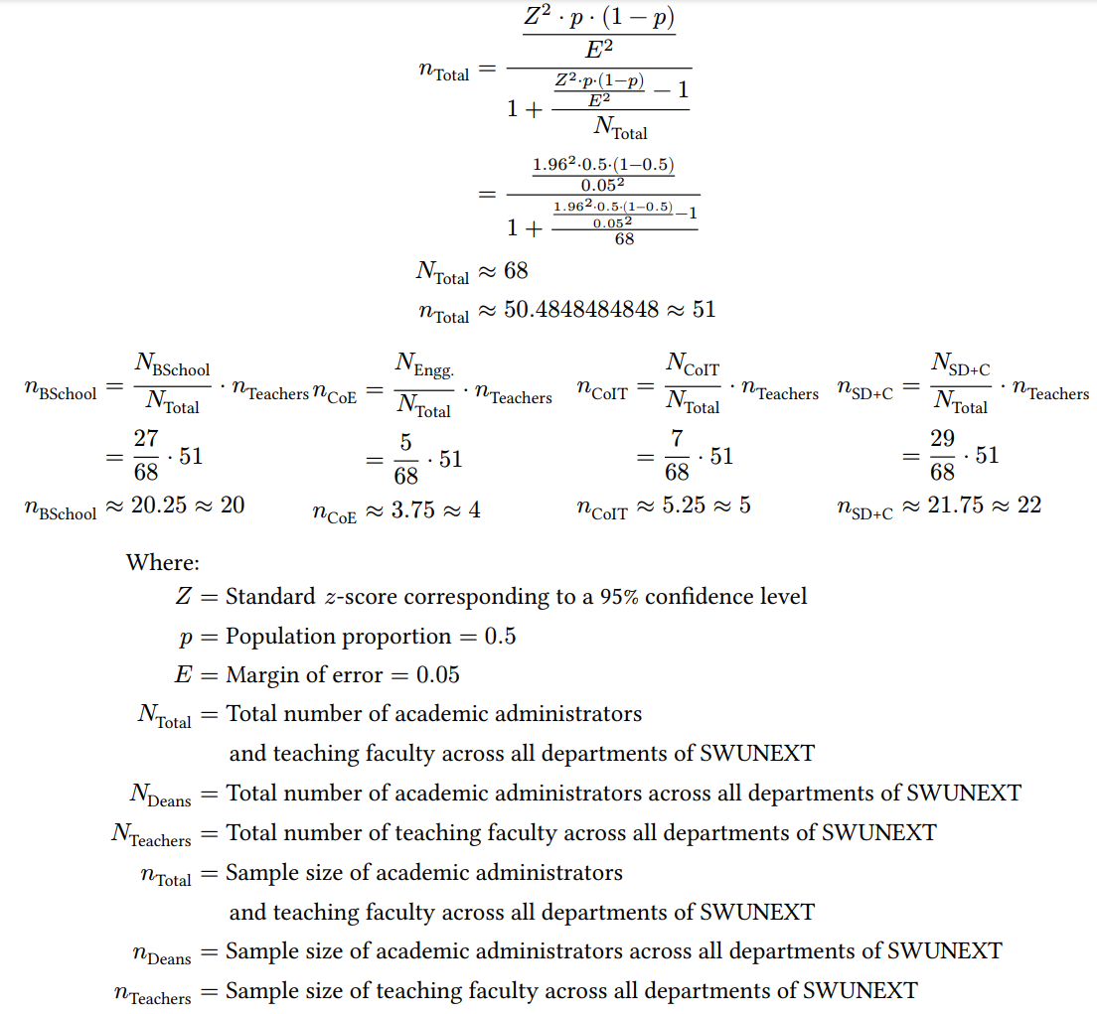
Figure 1. Sample Size Calculation
The researchers opted for a confidence level of 95% to account for values within two standard deviations from the mean and a 5% margin of error to account for errors made during the sampling process. Table 2 identifies the sample sizes across each department using Cochran’s formula, respectively.
Respondent Group | Population Size | Faculty Sample Size | Academic Administrator Sample Size | Total Sample Size
Business School | 27 | 17 | 3 | 20
College of Engineering | 5 | 2 | 2 | 4
College of Information Technology | 7 | 4 | 1 | 5
School of Design and Communication | 29 | 18 | 4 | 22
Total | 68 | 41 | 10 | 51
Table 2. Sample Size of Respondents

Data Gathering Tools and Techniques
The data gathering process will be divided into two phases, the pre-development phase and the post development phase. For the pre-development phase, the collection of quantitative data in relation to Research Question 1 and Research Question 2 will involve surveys with the selected teaching faculty members and academic administrators in order to collect their insights and experiences on the processes involved in assessing and monitoring student performance as well as the challenges faced by selected teaching faculty members and academic administrators in assessing and monitoring student performance. For the post-development phase, the collection of quantitative data in relation to Research Question 3 will involve a post-development survey with selected faculty members and academic administrators of colleges and schools affiliated with the SWUNEXT cluster, after the development of the proposed AI-Based Student Performance Evaluation and Monitoring System in order to assess the proposed system’s effectiveness in enhancing the academic decision making and data security aspects of the student performance evaluation and monitoring processes in academic institutions, and thereby addressing the identified challenges, gaps, and inefficiencies in the existing student performance evaluation and monitoring processes.

Procedures for Data Collection
The following sub-sections outline the techniques, procedures, and specifications of the data collection process for both the pre-development and post-development phases. The sub-sections shall cover the research instrumentation, medium and modality of data collection, subject matter of the data collected, and applicable ethical considerations.

Pre-Development Phase
The researchers shall observe the following techniques, procedures, and specifications in conducting the pre-development survey in relation to Research Question 1 and Research Question 2:
- The survey shall be conducted with the selected faculty members and academic administrators of colleges and schools affiliated with the SWUNEXT cluster, as selected via stratified random sampling, and can be conducted either via asynchronous distribution of survey questionnaires, or with the guidance of the researchers.
- A survey questionnaire shall serve as the research instrument, consisting of fifteen close-ended questions measuring the processes involved in assessing and monitoring student performance and the challenges faced by the faculty members in evaluating and monitoring their students’ performance throughout the semester, in terms of academic decision-making and data security. The survey includes topics such as:
  - Demographic Information, which includes the College / Department, and the role or position of the respondent group, and their teaching or administrative experience in student performance monitoring (as applicable). Participants may also opt to include their contact number or student number for verification purposes;
  - Current Practices in Student Performance Evaluation and Monitoring, which includes the procedures and tools used in the student performance evaluation and monitoring process; and
  - Challenges in Student Performance Evaluation and Monitoring, which includes the challenges faced by faculty members and academic administrators in assessing and monitoring student performance.
- The survey questions and responses shall conform to either a nominal level of measurement or an ordinal level of measurement using ranked choice, or a five-point Likert-type scale, with a neutral value, shall be presented in a table format, and shall be clustered in accordance with each research sub-question.
- The survey questionnaire shall be administered via Google Forms and shall contain the raw recorded responses. The responses of each participant will be exported for statistical analysis and visualization.
- In lieu of the absence of the Institutional Review Board’s evaluation of the study, the following procedures shall be observed due to ethical considerations:
  - Prior to the start of , a request letter shall be submitted to and signed by the Deans of each faculty member or academic administrator’s college or department.
  - Prior to the conduct of the survey with each participant, a Participant Information Sheet and Informed Consent Form must be read and signed by the participant, in order to obtain the consent of each participant. The selection of the analogous option in the Google Form shall serve as a sufficient proof of consent in cases where the researchers have not interacted face-to-face with the respondent.

Post-Development Phase
The researchers shall observe the following techniques, procedures, and specifications in conducting the post-development survey in relation to Research Question 4:
- The survey shall be conducted with the selected faculty members and academic administrators of colleges and schools affiliated with the SWUNEXT cluster, as selected via stratified random sampling, and can be conducted either via asynchronous distribution of survey questionnaires, or with the guidance of the researchers after the development of the proposed AI-Based Student Performance Evaluation and Monitoring System has been completed and the participants have interacted with the completed system.
- A survey questionnaire shall serve as the research instrument, consisting of fifteen close-ended questions measuring the faculty members and academic administrators’ level of acceptability of the then-completed AI-Based Student Performance Evaluation and Monitoring System in terms of efficiency, accuracy, relevance of information retrieval, and data security, and thereby addressing the identified challenges faced by faculty members and academic administrators of colleges and schools within the SWUNEXT cluster, in assessing and monitoring students’ performance.
- The survey questions and responses shall conform to either a nominal level of measurement or an ordinal level of measurement using a five-point Likert-type scale, with a neutral value, shall be presented in a table format, and shall be clustered in accordance with each research sub-question.
- The survey shall also contain a section with open-ended questions for any feedback provided by the participants.
- The survey questionnaire shall be administered via Google Forms and shall contain the raw recorded responses. The responses of each participant will be exported for statistical analysis and visualization.
- In lieu of the absence of the Institutional Review Board’s evaluation of the study, the following procedures shall be observed due to ethical considerations:
  - Prior to the start of , a request letter shall be submitted to and signed by the Deans of each faculty member or academic administrator’s college or department.
  - Prior to the conduct of the survey with each participant, a Participant Information Sheet and Informed Consent Form must be read and signed by the participant, in order to obtain the consent of each participant. The selection of the analogous option in the Google Form shall serve as a sufficient proof of consent in cases where the researchers have not interacted face-to-face with the respondent during the data collection process.

Project Timeline and Milestones
A research timeline outlines the significant milestones and activities throughout a research project, facilitating the efficient allocation of time, ensuring the project’s feasibility, organization, alignment with its intended research objectives, and its timely completion (Ali & Kamraju, 2023). The particulars of the capstone project and manuscript have undergone various changes and revisions, thus the particulars of each step of the capstone project are presented logically instead of chronologically. The overall timeline of the capstone project is separated into two timelines; Table 3 outlines the timeline of the capstone manuscript.

Phase | Particulars | Task / Objective | Target Date of Completion | Milestone Indicator
Initiation | Group Formation | Formation of group members | January 6, 2026 | Registered group code
Initiation | Letter of Intent and Acceptance of Project Proposition | Express intent of capstone project and receive acceptance of project proposition from validating officer | March 10, 2026 | Signed Letter of Intent and Acceptance of Project Proposition
Planning | Project Proposal and Title Defense | Formulate project idea and project title | February 27, 2026 | Approved capstone project proposal and project title
Planning | Chapter 1 - Introduction | Formulate background, research problem, research questions, research objectives, scope and limitations, significance of the study, and definition of terms | March 9, 2026 | Chapter 1 completed
Planning | RRL Inventory | Collect, organize, annotate, paraphrase and cite sources needed for Chapter 2 | March 20, 2026 | RRL inventory document
Planning | Chapter 2 - Review of Related Literature | Narrate current state of research, analyze related literature, summarize and synthesize themes among related literature, and Identify research gaps | March 20, 2026 | Chapter 2 completed
Planning | Chapter 3 - System Architecture and Methodology | Formulate research framework and design, research problem, data collection tools, techniques, and procedures, data analysis tools and techniques, system architecture, system development methodology, tools and platforms, system features, project timeline and cost estimates, architectural diagrams, and prototypes | March 20, 2026 | Chapter 3 completed
Execution | Pre-Development Phase 1 | Collect informed consent from participants and conduct pre-development survey in relation to RQ1 and RQ2 | March 25, 2026 | Data collected for RQ1
Execution | Data Analysis for RQ1 and RQ2 | Analyze collected data from survey in relation to RQ1 and RQ2 | March 25, 2026 | Chapter 4 partly written with results and findings for RQ1 and RQ2
Execution | Proposal Defense | Present capstone project proposal and findings in relation to RQ1 and RQ2 | March 25-31, 2026 | Proposal defense completed
Execution | Pre-Development Phase 2 | Perform systematic literature review in relation to RQ3 | April 10, 2026 | Data collected for RQ3
Execution | Data Analysis for RQ3 | Analyze collected data from the interview in relation to RQ3 | July 24, 2026 | Chapter 4 partly written with results and findings for RQ3
Execution | Post-  Development Phase | Collect informed consent from participants and conduct post-development survey in relation to RQ4 | October 16, 2026 | Data collected for RQ4
Execution | Data Analysis for RQ4 | Analyze collected data from the post-development survey in relation to RQ4 | October 30, 2026 | Data analyzed and visualized for RQ4
Execution | Chapter 4- Results and Discussion | Narrate interpretation and analysis of results for each phase in relation to RQ1-RQ4 | November 6, 2026 | Chapter 4 completed with results and findings for RQ1-RQ4 with visualizations
Execution | Chapter 5 - Conclusion and Recommendations | Synthesize conclusion and recommendations based on the results and findings in Chapter 4 | November 6, 2026 | Chapter 5 completed
Execution | Manuscript Revision | Perform final content, style, and formatting revisions | November 13, 2026 | Manuscript ready for final defense
Closure | Final Oral Defense | Present the capstone project to the panel | November 20, 2026 | Final defense completed
Table 3. Capstone Manuscript Timeline

Project Estimated Cost
Table 4 provides a detailed breakdown of all necessary material, administrative, labor, and resource subscription costs related to the manuscript writing and publication, data collection, system development and defense of the capstone project.
Item | Description | Item Cost | Quantity | Subtotal
Material and Administrative Costs
1 | Manuscript Printing Costs | ₱1.00  / page | (4 chapters x ~30 pages  + 1 chapter x ~100 pages)  x ~8 revisions = 1,760 pages | ₱1,700.00
2 | Participant Information Sheet and Informed Consent Form Printing Costs | ₱1.00  / page | (~73 respondents x 2 instruments  ~448 respondents x 1 instrument)  x 4 pages = 2,376 pages | ₱2,376.00
3 | Capstone Adviser Notary Fee | ₱500.00 | 1 | ₱500.00
4 | Capstone Advisory Fees | ₱5,000.00 | 2 | ₱10,000.00
5 | Proposal Defense Fee | ₱ 3,000.00 | 1 | ₱ 3,000.00
6 | Post-Survey Questionnaire Printing Costs | ₱1.00  / page | (~448 respondents x 8 pages)  = 3,584 pages | ₱3,584.00
7 | Final Manuscript Printing Costs | ₱ 1.00  / page | (4 chapters x ~30 pages  + 1 chapter x ~100 pages)  x ~5 copies = 880 pages | ₱880.00
8 | Bookbinding Costs | ₱ 1,000.00 / copy | 6 copies | ₱ 6,000.00
9 | Final Defense Fee | ₱ 3,000.00 | 1 | ₱ 3,000.00
Material and Administrative Cost Subtotal |  |  |  | ₱29,340.00
System Development Costs
10 | AI Subscription Costs | $ 10.00 / 1M tokens | 1M tokens | ₱ 5,921.97
11 | Supabase Subscription Costs | $25.00  / month | 6 months x 2 developers  = 12 periods | ₱ 17,757.63
Development Cost Subtotal |  |  |  | ₱23,679.60
Grand Total |  |  |  | ₱53,019.60

Table 4: Estimated Project Costs

Software Development Methodology
The researchers will employ the use of the Agile software development methodology in the development of the proposed system. The Agile methodology was selected for its incremental and iterative approach, which allows for flexibility, stakeholder involvement, and continuous improvement throughout the development process (Tetteh, 2024). The Agile methodology is suitable for the development of the proposed AI-Based Student Performance Evaluation and Monitoring System as it allows the seamless integration of the study’s results and findings, as well as miscellaneous feedback gathered from the respondents of the study. Figure 2 illustrates the phases of the Agile software development methodology.
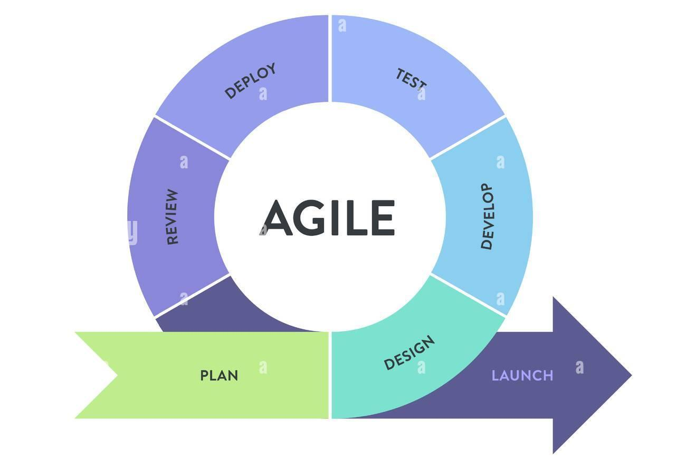
Figure 2. Agile Methodology
Kanban Framework
Kanban is a project management framework that is commonly used for the visual implementation of Agile principles in software development and other industries, and emphasizes flexibility, workflow visualization, work-in-progress minimization, optimal project resource allocation, incremental improvement, and risk mitigation (Tetteh, 2024).
In the Kanban framework, work items are visualized as cards and placed in a Kanban board, a tabular form of visualizing a project’s progress. Lanes are used to denote specific categories of work and resource allocation, depending on a work item’s status within the project, and are visualized as columns in the Kanban board. Each lane is limited by a maximum number of tasks allowed to be performed at the same time, also known as a lane’s capacity. Figure 3 illustrates the Kanban Framework via a Kanban board.
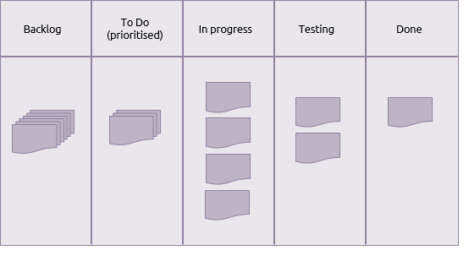
Figure 3. Kanban Framework
The following process shall be used in the development workflow of the proposed system:
- Backlog - Data gathered from research participants and other stakeholders, requirements analysis, and other phases are analyzed, converted into functional requirements, and a corresponding card is placed onto the Backlog lane, which represents the complete scope of work to be performed and indicates all the possible tasks and features to be implemented. This phase corresponds to the Plan and Design phases of the Agile software development methodology.
- To Do - A number of cards shall be moved from the Backlog lane onto the To Do lane, which indicates the work items that have been prioritized and are ready to be performed. Each card in the To Do lane must be categorized by their importance, the start and completion dates of each work item must be scheduled, and the responsible person and resources must be noted in each card. This phase corresponds to the Plan phase of the Agile software development methodology.
- In Progress - Once the development team has ample resources to complete a new task, a task shall be moved from the To Do lane onto the In Progress lane, which indicates the tasks that are currently being performed. The status of each work item is noted as the implementation progresses. This phase corresponds to the Develop phase of the Agile software development methodology.
- Blocked - If the implementation of an in-progress work item cannot proceed due to an issue, the corresponding card is placed onto the Blocked lane while the analysis or resolution of the issue takes place. Once the issue has been resolved, it can proceed to either the In Review lane once the work item has been completed, or the Backlog lane if the work item has been deprioritized.
- In Review - Once the implementation of the work item has been completed, the corresponding card is moved onto the In Review lane, which represents the testing, feedback, and validation process of each work item. Various feedback by testers, research participants, and other stakeholders regarding the implementation of the work item are documented in each card, and if further work is required to be done, additional cards shall be placed onto the Backlog lane. This phase corresponds to the Review, Deploy, and Test phases of the Agile software development methodology, as well as its iterative feedback mechanism.
- Done - Once a work item has been implemented and the testing, feedback, and validation process has been completed, its corresponding card is placed in the Done lane, which indicates the completion of a work item. The completion date is indicated, and future improvements, lessons learned, and other feedback is documented in this card. This phase corresponds to the Launch phase of the Agile software development methodology.

Software Development Tools
The development of the proposed AI-Based Student Performance Evaluation and Monitoring System utilizes a collection of software development tools and platforms. Table 5 outlines the list of major software development tools and platforms used during the development of the system.
Logo | Tool / Platform Description | Usage in the System
 | Supabase is an open-source platform that provides managed database, authentication, identity, and storage services. | Serves as a backend of the system; Provides database, storage, and identity management, secure authentication, and API integration.
 | JavaScript is a high-level, general-purpose programming language commonly used for web applications. | Language used to develop the user-facing application and the inference API service.
 | React Native is an open-source framework based on React JS; used for the development of dynamic, cross-platform user interfaces. | Framework used to create the mobile and web frontend using a single codebase.
 | Nativewind is a styling library for React Native. | Provides consistent and responsive user interface layouts and styles for mobile and web.
 | Expo is a full-stack React Native-based framework and platform for developing, building, and deploying React Native applications. | Provides an SDK, an execution sandbox, and build and deployment services for the user-facing application.
 | Python is a high-level, general-purpose programming language; considered the “de-facto standard for AI” (Müller, 2025). | Language used to develop the agentic AI framework and the domain-specific AI models utilized throughout the system.
 | PyTorch is an open-source machine learning library written in Python. | Used to implement the LSTM / Transformer based models for student performance evaluation and prediction.
 | SHapley Additive exPlanations (SHAP) is a Python module that calculates the contribution of input features to the output of machine learning models (Rasheed et al., 2022). | Used to identify features with the highest contribution to student performance evaluation and prediction outputs.
 | Pydantic-AI is an open-source, type-safe, AI agent framework written in Python. | Used to develop agentic AI workflows for the generation of class record templates and personalized feedback notifications.
 | Docker is an OS-level virtualization platform that enables the development, deployment, and management of applications. | Used for the consistent and effective packaging and deployment of the AI inference service.
 | GitHub is a Git-based version control and collaboration platform-as-a-service. | Source code storage, version control, and collaboration during the development of the system.
 | Visual Studio Code (VS Code) is a code editor with syntax highlighting, terminal, code completion, extensions, and Git integration. | Used as the system’s primary integrated development environment.
 | Figma is a collaborative vector-based user-interface and user experience design application. | Used for designing medium-fidelity interactive prototypes of the cross-platform user interface.
 | JupyterLab is a web-based interactive development environment for data science and machine learning. | Used as the development and visualization environment for the performance evaluation and prediction models.

Table 5. Software Development Tools and Platforms

Data Analysis Tools and Techniques
The quantitative data collected in addressing Research Question 1, Research Question 2, and Research Question 4 through survey questionnaires answered by faculty members and academic administrators shall be exported into a digital format in order to preserve the accuracy and completeness of the data. The exported responses shall be categorized according to the questions and the corresponding Research Questions, and the frequency of each response for each question among all the participants shall be calculated directly using the quantitative data analysis software, and appropriate measures of central tendency shall be applied in accordance with the level of measurement of the data.

Descriptive Statistics
Descriptive statistics, such as weighted mean, median, mode, and standard deviation, will be calculated from the responses of the close-ended questions of the pre- and post-development survey questionnaires using the Microsoft Power BI software.

- Percentage
The percentage measure shall be used to describe the distribution of the demographic profiles of the research participants. Figure 4 shows the formula for calculating the percentage:
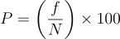
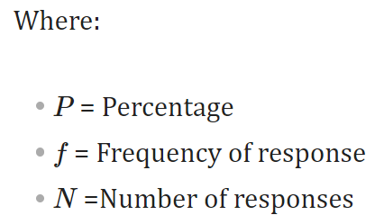
Figure 4. Percentage Formula
- Weighted Mean
The weighted mean measure shall be used to calculate the sample mean of the scores assigned as responses to the Likert-type scale questions in the survey questionnaires. Figure 5 shows the weighted sample mean formula:
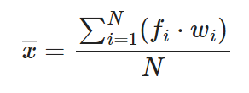
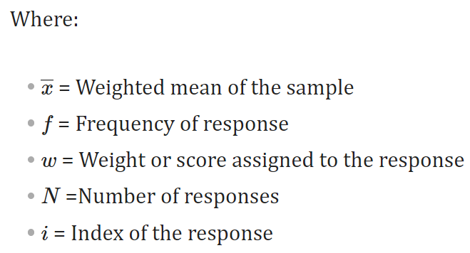
Figure 5. Weighted Mean Formula

- Standard Deviation
The standard deviation measure shall be used to calculate the variation or dispersion of the scores assigned as responses to the Likert-type scale questions in the survey questionnaires, from the scores’ weighted sample mean. Figure 6 shows the sample standard deviation formula:
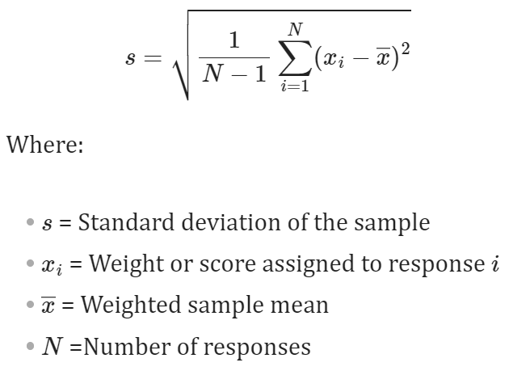
Figure 6. Standard Deviation Formula
Based on the maximum standard deviation method of Croucher (2004), the researchers use an equal-interval classification method for the standard deviation, where a “Low” standard deviation is between the interval [0, s_{max} /3], a “Medium” standard deviation is between the interval [s_{max} /3, 2 s_{max} /3], and a “High” standard deviation is between the interval [2 s_{max} /3, s_{max}]. Figure 7 shows the formula for calculating the maximum sample standard deviation over an interval, s_{max}.

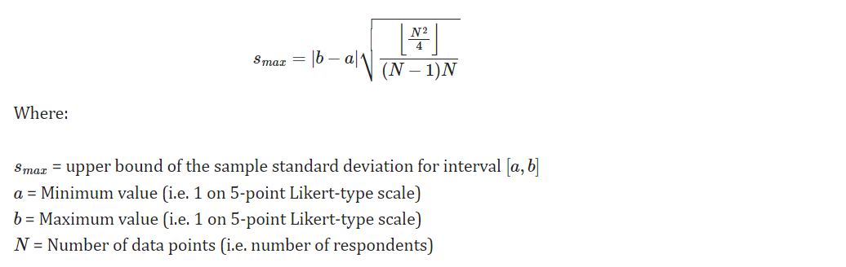
Figure 7. Maximum Sample Standard Deviation Formula

Microsoft Power BI
Microsoft Power BI is a proprietary interactive data analysis and visualization software that focuses on business intelligence. Microsoft Power BI serves as the primary quantitative data analysis and visualization software, and will be used to pre-process and analyze the survey questionnaire responses using descriptive statistics and create interactive visualization dashboards for a graphical presentation of the analysis results.
Figure 8 shows the icon of PowerBI.

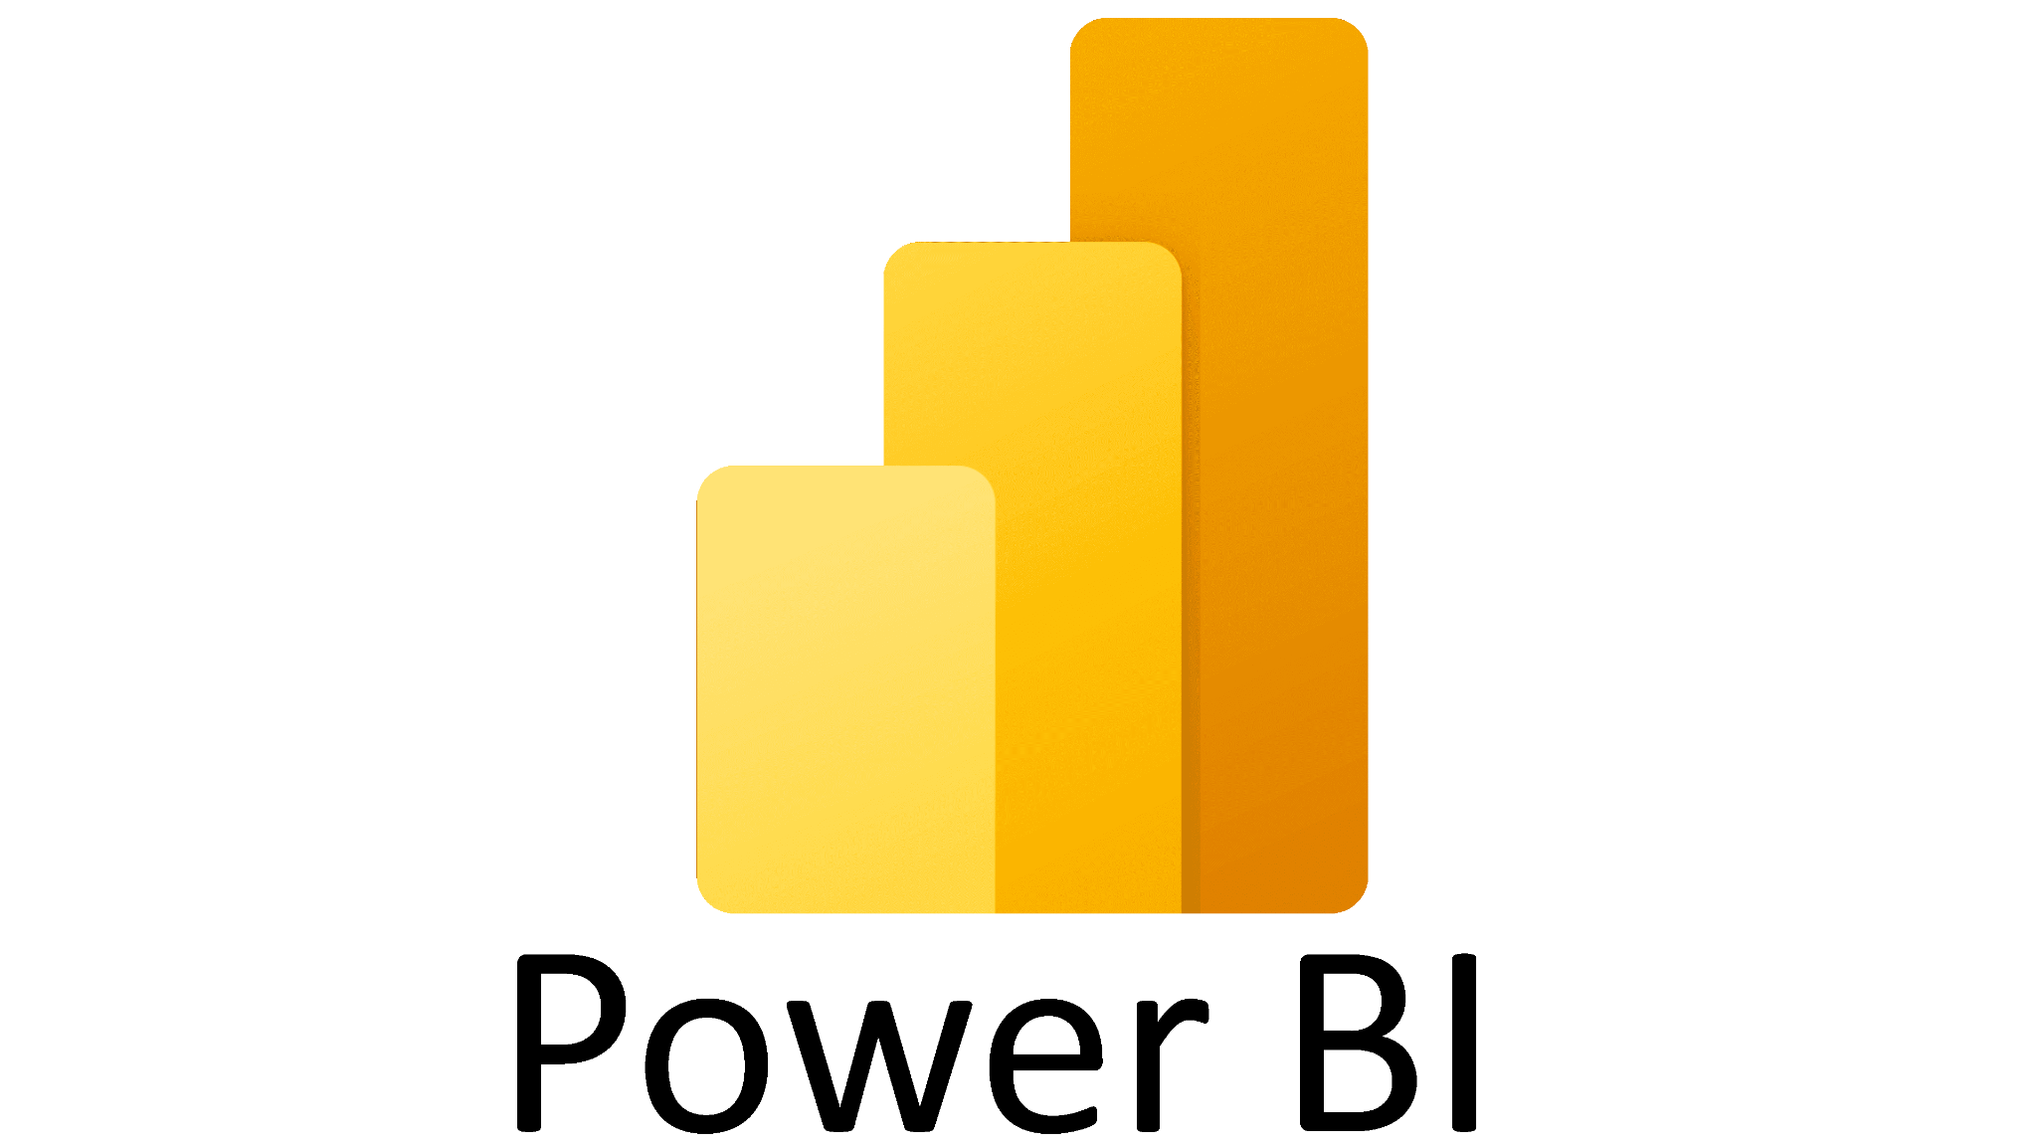
Figure 8. PowerBI

CHAPTER 4

RESULTS AND DISCUSSION
This chapter presents the analysis and interpretation of results obtained from the data collection process conducted throughout the study. The discussion is structured to discuss the response rate of the data collection, the demographic profile and the results of the pre-development survey in addressing Research Question 1 and Research Question 2, focusing on perceptions of the processes involved in student performance evaluation and monitoring among faculty members and academic administrators within the SWUNEXT cluster, as well as the identified challenges in the current student performance evaluation and monitoring processes faced by faculty members and academic administrators within the SWUNEXT cluster.

Response Rate
Out of an overall sample size of 51 faculty members and academic administrators across all colleges and schools affiliated with the SWUNEXT cluster as calculated using Cochran’s formula, 40 responses were successfully collected, resulting in an overall response rate of 78.43%. This response rate provides a robust and representative baseline for examining the existing processes and challenges encountered by faculty members and academic administrators within the SWUNEXT cluster. Table 6 shows the response rate of the study as categorized by the role of each respondent group.

Respondent Group | Sample Size | Number of Responses | Response Rate
Faculty | 41 | 36 | 87.80%
Academic Administrators | 10 | 4 | 40.00%
Total | 51 | 40 | 78.43%
Table 6. Response Rate According to Respondent Roles

Table 7 shows the response rate of the study as according to the college or department of the respondents.

Respondent Group | Sample Size | Number of Responses | Response Rate
Business School | 20 | 12 | 60.00%
College of Engineering | 4 | 4 | 100.00%
College of Information Technology | 5 | 4 | 80.00%
School of Design and Communication | 22 | 20 | 90.91%
Total | 51 | 40 | 78.43%
Table 7. Response Rate According to College / Department

Demographics
Among the thirty-six faculty respondents, nineteen (19) of the respondents are faculty members of the School of Design and Communication, eleven (11) of the respondents are faculty members of the Business School, three (3) respondents are faculty members of the College of Information Technology and three (3) respondents are faculty members of the College of Engineering. Figure 9 shows the distribution of faculty respondents by their respective college or department.
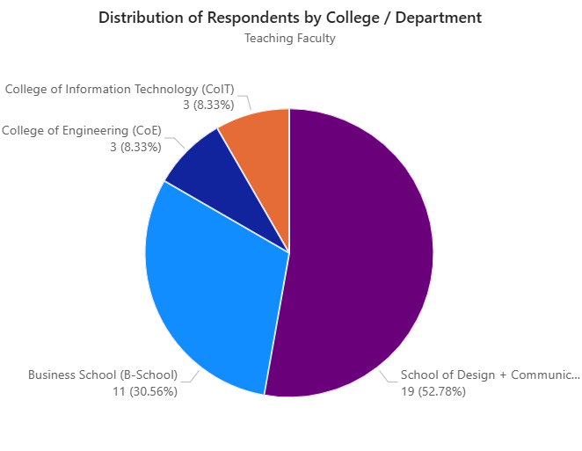
Figure 9. Distribution of Faculty Respondents by College / Department
Among the four academic administrators who completed the pre-development survey, one of the respondents is an academic administrator of the School of Design and Communication, one of the respondents is an academic administrator of the College of Engineering, one of the respondents is an academic administrator of the College of Information Technology, and one of the respondents is an academic administrator of the Business School. Figure 10 shows the distribution of academic administrator respondents by their respective college or department.
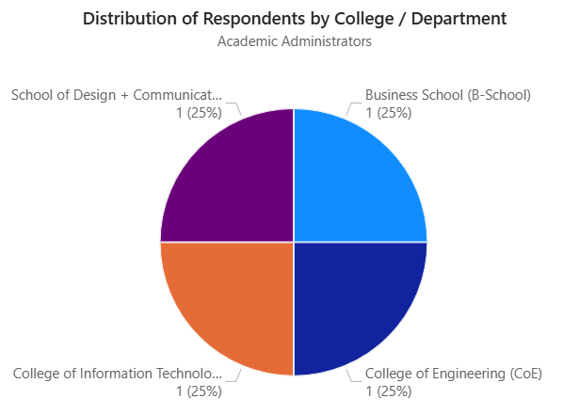
Figure 10. Distribution of Academic Administrator Respondents by College / Department
Among the four academic administrators who completed the pre-development survey, two (2) of the respondents are Program Heads, one of the respondents is a Dean,and one of the respondents is an Assistant Dean. Figure 11 shows the distribution of academic administrator respondents by their position.
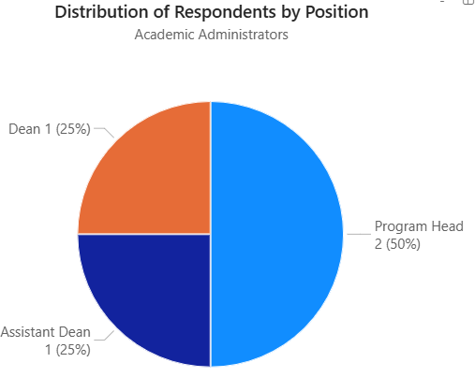
Figure 11. Distribution of Academic Administrator Respondents by Position

Processes Involved in Student Performance Evaluation and Monitoring Among SWUNEXT Faculty and Academic Administrators
The existing processes for evaluating and monitoring student performance among academic administrators of colleges and schools affiliated with the SWUNEXT cluster are analyzed using a process flow diagram, also known as a ‘flowchart’. A process flow diagram indicates the ordered sequence of operations or procedures performed in a process. The arrows in the process flow diagram represent the transition from one procedure in the process to another, while the parenthesized numeric labels on the arrows indicate the number of academic administrators who perform the procedures in the particular order or sequence indicated by the arrow. Figure 12 visualizes the current process flow performed by academic administrators of colleges and schools affiliated with the SWUNEXT cluster in assessing and monitoring student performance.
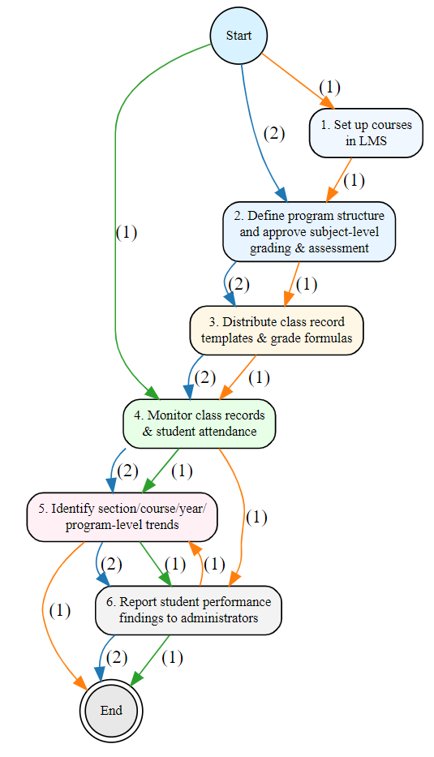
Figure 12. Current Student Performance Evaluation and Monitoring
Process Flow for Academic Administrators within SWUNEXT

The procedures being performed most frequently by academic administrators within SWUNEXT in evaluating and monitoring student performance are the monitoring of class records and student attendance reports from faculty, the identification of section/course/year/program-level trends in student performance, and the reporting of student performance findings to institutional administrators, with the highest mean scores of 4.50 (Often) and the lowest standard deviation of 0.58 (Low), which indicates a high level of agreement between academic administrators of their frequent application of these procedures, while the procedure being performed most infrequently is “Distributing access to learning management systems” with the lowest mean score of 1.50 (Rarely) and the lowest standard deviation of 0.58 (Low), which indicates a high level of agreement between academic administrators of their infrequent application of this procedure. These results suggest that academic administrators are primarily focused on late-stage monitoring and reporting phases, while the initial setup tasks are perceived as significantly less frequent. Table 8 shows the frequency in which each of the identified procedures in the current process are performed by academic administrators within SWUNEXT in evaluating and monitoring student performance.
 | Procedure | Count | Mean | Median | Mode | Standard Deviation
1. | Define program structure and approve subject-level grading and assessment policies | 4 | 2.00 | 2.00 | 2 | 0.82
2. | Distribute access to classes in learning management systems | 4 | 1.50 | 1.50 | 1 | 0.58
3. | Distribute class record templates and grade calculation formulas | 4 | 2.00 | 2.00 | 2 | 0.82
4. | Monitor class records and student attendance reports from faculty | 4 | 4.50 | 4.50 | 4 | 0.58
5. | Identify section/course/year/  program-level trends in student performance | 4 | 4.50 | 4.50 | 4 | 0.58
6. | Report student performance findings to institutional administrators | 4 | 4.50 | 4.50 | 4 | 0.58
Table 8. Frequency of Each Procedure in the Student Performance Evaluation
and Monitoring Process for Academic Administrators within SWUNEXT
The existing processes for evaluating and monitoring student performance among the faculty members of colleges and schools affiliated with the SWUNEXT cluster are analyzed using an incidence matrix. An incidence matrix indicates a relationship or correspondence between two objects, in this case, the correspondence between the operations or procedures performed in the current student performance evaluation and monitoring process and their relative order for each faculty’s process flow. The columns indicate the relative order in which a procedure is performed (e.g. 1st to 12th in the process) while the numeric cell entries indicate the number of faculty members who assign the particular procedure to the particular order in their process flow. The entries in the N/A column indicate that the particular procedure is not performed in a faculty member’s current student performance evaluation and monitoring process flow. Table 9 suggests that the most common sequence of procedures performed by faculty members of colleges and schools affiliated with the SWUNEXT cluster are the definition of student assessment methods and assessment-level grading criteria, setup of courses in learning management systems, delivery of course instruction, collection and recording of student attendance and engagement data, conduct of student check-ups or observations, delivery of student assessments and checking of assessment outputs, recording of student assessment results to class records, calculation of student grades after assessment results, identification and/or prediction of student performance trends, monitoring of performance of students who are at risk of failure, conduct of student intervention measures, and lastly, the creation and submission of student performance reports. The incidence matrix suggests the overall linear progression of student performance evaluation and monitoring tasks, yet the wide dispersion in check-ups and observation suggests an inconsistent approach to student observation. Table 9 visualizes the incidence matrix showing the current spectrum of process flows performed by academic administrators of colleges and schools affiliated with the SWUNEXT cluster in assessing and monitoring student performance.

Procedure | 1st | 2nd | 3rd | 4th | 5th | 6th | 7th | 8th | 9th | 10th | 11th | 12th | N/A
Define student assessment methods and assessment-level grading criteria | 22 | 1 |  |  | 3 | 1 |  |  |  | 1 |  |  | 8
Set up course in learning management system | 3 | 22 |  |  | 1 |  | 1 | 1 |  |  |  |  | 8
Deliver course instruction (e.g. teacher-led or student-led) | 8 | 4 | 22 | 1 | 1
Collect and record student attendance and engagement data | 1 | 7 | 3 | 20 | 3 | 1 | 1
Perform student check-ups or observations | 1 |  | 5 | 2 | 16 | 2 |  | 1 | 2 | 3 | 2 | 2
Deliver student assessments and check assessment outputs | 1 |  | 3 | 6 | 4 | 19 |  | 3
Record student assessment results to class records | 1 |  | 1 | 4 | 6 | 5 | 18 |  | 1
Calculate student grades after assessment results | 1 |  |  |  | 4 | 6 | 5 | 18 |  | 2
Identify and/or forecast student performance trends |  |  |  |  |  | 2 | 7 | 4 | 17 |  | 3 |  | 3
Monitor the performance of students who are at risk of failure |  | 1 |  |  |  | 2 | 1 | 7 | 7 | 17 | 1
Perform student interventions |  |  |  | 1 | 2 | 2 | 1 | 1 | 6 | 4 | 18 | 1
Write and submit student performance reports |  |  |  |  | 1 | 4 | 2 | 1 | 1 | 7 | 3 | 17
Table 9. Incidence Matrix of Current Student Performance Evaluation
and Monitoring Process Flow for Faculty Members within SWUNEXT
The procedure being performed most frequently by faculty members within SWUNEXT in evaluating and monitoring student performance is the collection and recording of student attendance and engagement data, with a mean score of 4.97 (Always), while the procedure being performed least frequently by faculty members within SWUNEXT in evaluating and monitoring student performance is the identification and prediction of student performance trends, with a mean score of 3.54 (Often). These results suggest that although the faculty members perform all the procedures relatively frequently, they prioritize the attendance, instruction, assessment, checking, recording and student performance reporting, while showing the lowest frequency in proactive monitoring tasks such as forecasting student performance trends and conducting student interventions. Table 10 shows the frequency in which each of the identified procedures in the current process are performed by academic administrators within SWUNEXT in evaluating and monitoring student performance.
 | Procedure | Count | Mean | Median | Mode | Standard Deviation
1. | Define student assessment methods and assessment-level grading criteria | 28 | 4.32 | 5.00 | 5 | 0.98
2. | Set up course in learning management system | 29 | 4.00 | 4.00 | 5 | 1.16
3. | Deliver course instruction (e.g. teacher-led or student-led) | 34 | 4.88 | 5.00 | 5 | 0.33
4. | Collect and record student attendance and engagement data | 34 | 4.97 | 5.00 | 5 | 0.17
5. | Perform student check-ups or observations | 34 | 3.82 | 4.00 | 3 | 0.94
6. | Deliver student assessments and check assessment outputs | 33 | 4.85 | 5.00 | 5 | 0.36
7. | Calculate student grades after assessment results | 33 | 4.70 | 5.00 | 5 | 0.53
8. | Record student assessment results to class records | 33 | 4.82 | 5.00 | 5 | 0.46
9. | Identify and/or forecast student performance trends | 33 | 3.54 | 3.00 | 3 | 0.97
10. | Monitor the performance of students who are at risk of failure | 34 | 4.06 | 4.00 | 4 | 0.89
11. | Perform student interventions | 34 | 3.65 | 4.00 | 3 | 1.10
12. | Write and submit student performance reports | 34 | 4.91 | 5.00 | 5 | 0.29
Table 10. Frequency of Each Procedure in the Student Performance Evaluation
and Monitoring Process for Faculty Members within SWUNEXT

Summary of Findings Related to Research Question 1
The findings for Research Question 1 indicate that the existing student performance evaluation and monitoring processes within the SWUNEXT cluster follow a linear and sequential process flow where faculty members prioritize the initial components of the process flow such as attendance and engagement monitoring, instruction delivery, and checking and recording of assessment results over proactive monitoring of student performance indicators, while academic administrators prioritize the terminal components of the process flow such as monitoring student performance, identification of performance trends, and reporting, suggesting an inconsistent approach to student performance evaluation and monitoring.

Challenges in Student Performance Evaluation and Monitoring Among SWUNEXT Faculty and Academic Administrators
The results on Table X suggest that the lack of integration between the different platforms currently used for student performance and monitoring is the foremost challenge faced by academic administrators in evaluating and monitoring student performance, with a mean score of 4.50 (Strongly Agree), followed by difficulties in comparing student performance data across different courses, sections, year levels, and degree programs, with a mean score of 4.25 (Agree), and the availability of student performance data in unstable situations, with a mean score of 4.00 (Agree). Meanwhile, the academic administrators showed an unclear perception of the difficulty in the early identification of students at risk of failure, with a mean score of 3.25 (Neutral), and the difficulty in the categorization of students according to risk levels, with a mean score of 3.00 (Neutral). Table 11 outlines the challenges faced by academic administrators in evaluating and monitoring student performance.
 | Statement | Count | Mean | Median | Mode | Standard Deviation
a. | Existing systems used in assessing and monitoring student performance lack integration with each other. | 4 | 4.50 | 5.00 | 5 | 1.00
b. | It is difficult to compare student performance across different courses (i.e. subjects), sections, year levels, and degree programs. | 4 | 4.25 | 4.50 | 5 | 0.96
c. | It is difficult to access student performance data when needed in situations involving unstable Internet connections, accidentally deleted files, faculty absences, etc. | 4 | 4.00 | 4.00 | 3 | 1.16
d. | It is difficult to obtain timely reports. | 4 | 4.00 | 4.00 | 4 | 0.00
e. | It is difficult to identify students at risk of failure early in a semester. | 4 | 3.25 | 3.50 | 1 | 1.71
f. | It is difficult to categorize students based on their performance levels (e.g., high, average, at-risk). | 4 | 3.00 | 3.50 | 4 | 1.41
Table 11. Challenges in Student Performance Evaluation and Monitoring
Among Academic Administrators within SWUNEXT
The results on Table X suggest that the difficulty in consolidating student performance data between different sources is the foremost challenge faced by faculty members in evaluating and monitoring student performance, with a mean score of 4.33 (Agree), followed by the time-consuming management of student performance records, with a mean score of 4.28 (Agree), lack of useful analytical insights in the currently used systems for student performance monitoring and the difficulty in student progress monitoring and the identification of at-risk students, with a mean score of 4.08 (Agree). Table 12 outlines the challenges faced by faculty members in evaluating and monitoring student performance.
 | Statement | Count | Mean | Median | Mode | Standard Deviation
a. | Data consolidation from different sources is difficult. | 36 | 4.33 | 4 | 5 | 0.72
b. | Managing student performance records is time-consuming. | 36 | 4.28 | 4 | 4 | 0.51
c. | Existing systems lack useful insights. | 36 | 4.08 | 4 | 4 | 0.65
d. | Identifying at-risk students is challenging. | 36 | 4.08 | 4 | 4 | 0.65
e. | Monitoring student progress is difficult. | 36 | 4.08 | 4 | 4 | 0.69
f. | There are instances of errors or inconsistencies in student academic records. | 36 | 3.94 | 4 | 4 | 0.58
g. | Data interpretation requires too much time. | 36 | 3.89 | 4 | 4 | 0.67
h. | Data security and privacy is a significant risk with the current student performance monitoring process. | 36 | 3.89 | 4 | 4 | 0.71
Table 12. Challenges in Student Performance Evaluation and
Monitoring Among Faculty Members within SWUNEXT

Summary of Findings Related to Research Question 2
The study identifies a misalignment between the existing student performance evaluation and monitoring processes and the requirements for effective academic decision-making. The survey results highlight the lack of integration and the difficulty of data consolidation between the different platforms and data sources currently used for student performance and monitoring as the main challenges faced by faculty members and academic administrators in assessing students and monitoring their performance, while the time-consuming management of student performance records, the difficulties in comparing student performance data across different cohorts and categories, the availability of student performance data in unstable situations, the lack of useful analytical insights in the currently used systems for student performance monitoring, and the difficulty in student progress monitoring and the identification of at-risk students in the current student performance evaluation and monitoring systems pose additional challenges to faculty members and academic administrators in evaluating and monitoring student performance. The identified challenges collectively emphasize the necessity for a centralized AI-based system that combines advanced analytical indicators and robust data security mechanisms to provide a more efficient, accurate, relevant, and secure student performance evaluation and monitoring process for faculty members and academic administrators of colleges and schools affiliated with the SWUNEXT cluster.

Conceptual Framework
The proposed AI-Based Student Performance Evaluation and Monitoring System follows a linear-iterative conceptual approach, with various inputs, processes, and outputs in each phase of the student performance evaluation and monitoring process, and continuously iterates upon the entry or modification of student assessment data, or upon system configuration. The system is accessible using a mobile app or the user’s web browser connected to the Internet, which itself is connected to the system’s backend.
The input process begins with the creation and configuration of user accounts, roles and permissions, access via login credentials, connection and importation of class data from external Learning Management Systems (LMS), and the creation of academic guidelines, class record templates, and class records. During the assessment process, assessment results are recorded into the system manually or through LMS integration. The transformation process of student assessment and performance data starts with the system’s automated calculation of student performance based on the recorded assessment results and defined calculation formulas. The assessment results are then provided to the machine learning models for performance evaluation and sequence to sequence prediction of assessment results and prediction of overall performance results. The machine learning model outputs are then processed by the large language model (LLM)-based artificial intelligence (AI) agent to provide personalized performance feedback for each student. The output process involves the presentation of student performance data through a REST API and its visualization in tabular and graphical formats in the system frontend. The output of the personalized student performance feedback is delivered to students via email.
Figure 13 illustrates the proposed system’s conceptual framework in the context of the system inputs and outputs, using the Input-Process Output model.
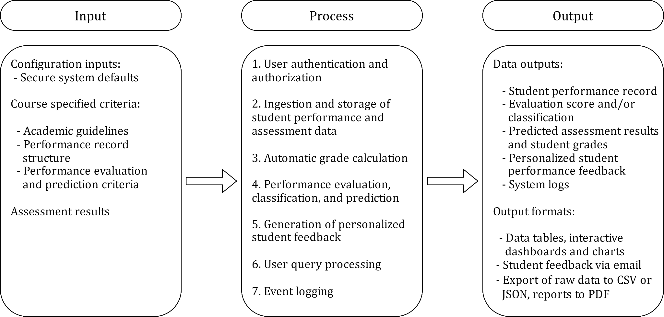
Figure 13. Conceptual Framework of the System Using the Input-Process-Output Model

Context Flow Diagram
A context flow diagram illustrates the overall flow of a system, and its inputs, outputs, and interactions with external entities. Figure 14 shows the context flow diagram of the proposed system.
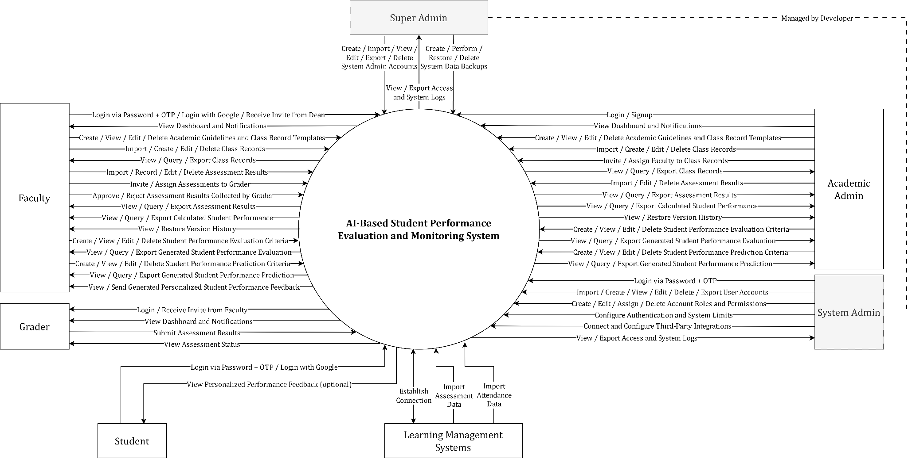
Figure 14. Context Flow Diagram
The context flow diagram visualizes the interactions between the proposed AI-Based Student Performance Evaluation and Monitoring System, with its six actors, Faculty, Academic Admin, System Admin, Super Admin, Grader, and Student, as well as its interactions with external entities such as Learning Management Systems. The system acts as a centralized information management platform that aggregates and processes academic data from various sources. The System Admin interacts with the system to perform technical configuration tasks in order to ensure the operation of the system. The Super Admin has a higher‑level but more limited scope of interaction with the system in facilitating the initial and backup configuration of the system. The System Admin and Super Admin actors do not represent faculty members or academic administrators of colleges and schools affiliated with the SWUNEXT cluster, but are, instead, external entities managed by the developers of the system. The Academic Admin interacts with the system to perform the administration of academic tasks such as the management of academic guidelines, management of class record templates, and monitoring of class records. The Faculty interacts with the system to create and manage student performance records and assessment results, review assessment results submitted by the Grader, perform student performance evaluation and prediction, and distribute personalized performance feedback to students. The Grader has a more limited scope of interaction than the Faculty in interacting with the system to perform assessment result entry in assistance to the Faculty. The Student has the most limited scope of interaction, being able to view the personalized student performance feedback generated by the Faculty.

Use- case Diagram
A use-case diagram is a type of Unified Modeling Language (UML) diagram that visualizes a system’s high-level functionality and possible interactions between users and the system (Mornie et al., 2026). Figure 15 outlines the list of actors and supported functional use cases that are necessary to the correct operation of the proposed AI-Based Student Performance Evaluation and Monitoring System in accordance with its system requirements.
The system consists of six actors, namely, Super Admin, System Admin, Academic Admin, Faculty, Grader, Student. The Super Admin and System Admin actors facilitate the technical administration of the system through the management of users, roles, permissions, logs, and backups, while the Academic Admin and Faculty actors facilitate the management of academic processes such as the management of class records, student assessment and performance data, and student performance evaluation, prediction, and feedback. The system also facilitates additional academic use-cases for Grader and Student actors, who are incidental to the student performance evaluation monitoring processes. The System Admin and Super Admin actors do not represent faculty members or academic administrators of colleges and schools affiliated with the SWUNEXT cluster, but are, instead, external entities managed by the developers of the system. The configuration of actors and use-cases in the system is enforced using a Role-Based Access Control mechanism and is designed with consideration to the data confidentiality and integrity of the system, in accordance with the principles of least privilege and separation of duties.
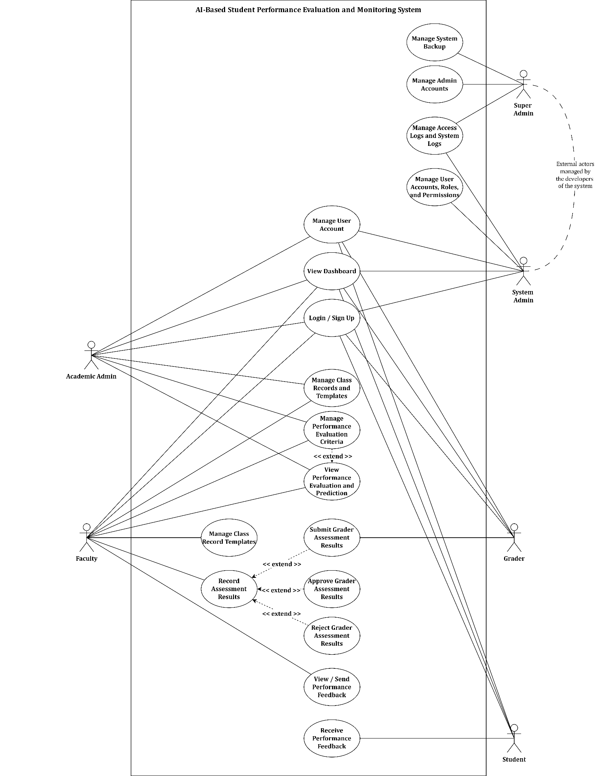
Figure 15. Use Case Diagram

Data Flow Diagram
According to Napolitano et al. (2024), a data flow diagram (DFD) visualizes the data flow within a system, including the entities, processes, and data stores involved in the data flow. The data flow diagram of the proposed AI-Based Student Performance Evaluation and Monitoring System shows the processes and the flow of information from the users of the system to the different modules and functions of the system. The data flow starts at the homepage, which serves as the initial interface and directs the user to login to the system. Once the user provides their credentials the system authenticates the user’s identity, and if the authentication is successful, the user is redirected to the Dashboard module, which serves as a centralized hub for users for viewing essential information and navigation points to other pages that provide various functionality, such as assessment recording, performance evaluation, management, among others, depending on their user roles. Figure 16 shows the data flow diagram of the proposed system.

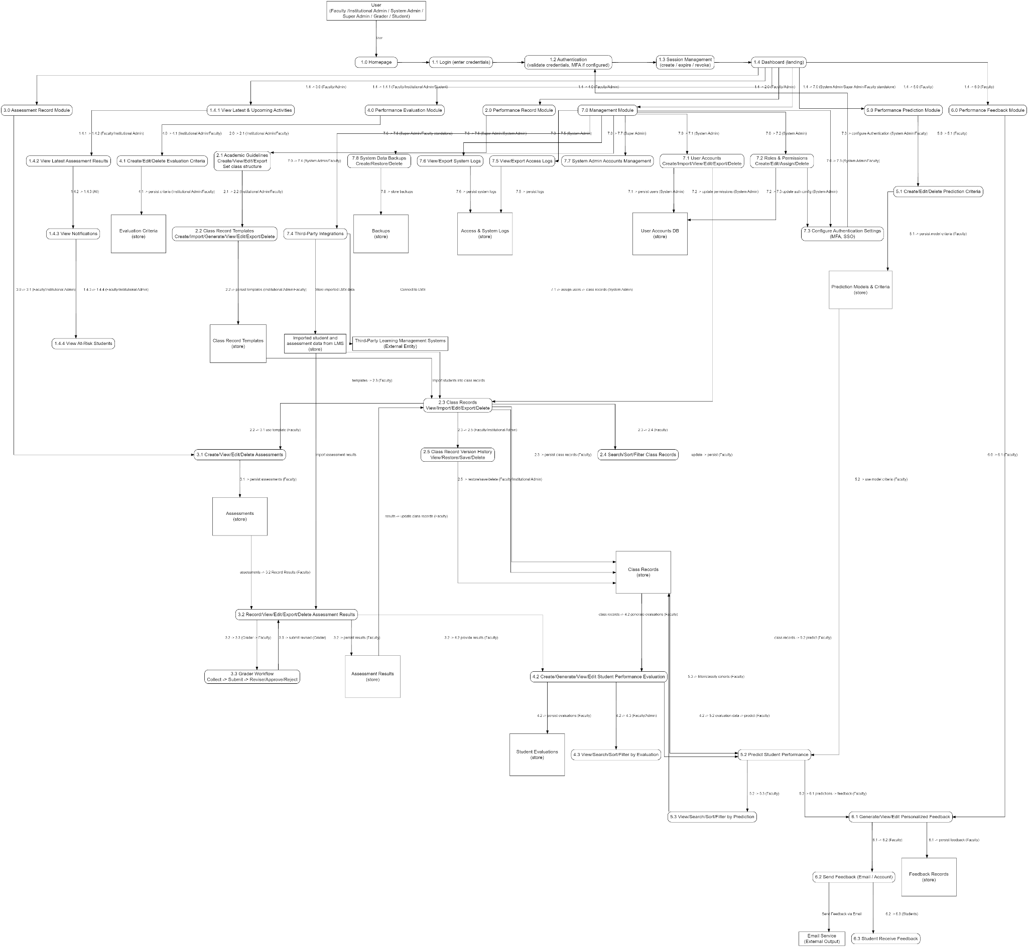
Figure 16. Data Flow Diagram

WIREFRAMES

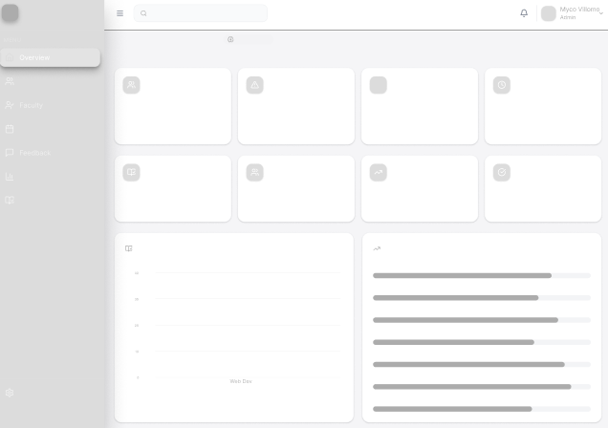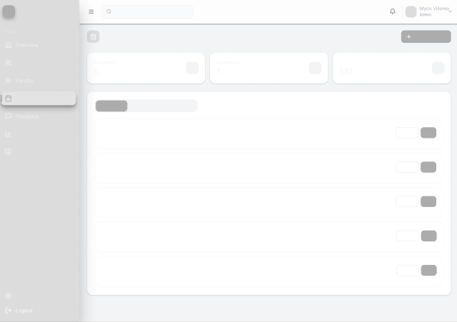
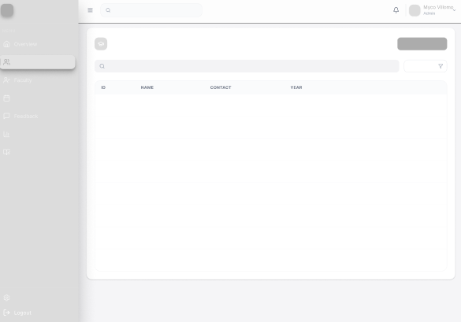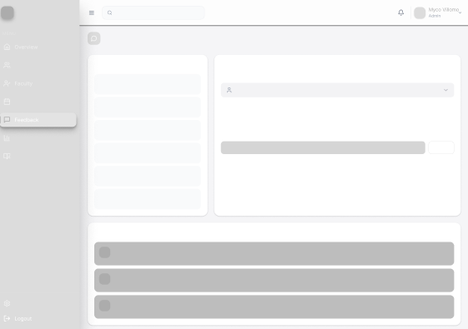
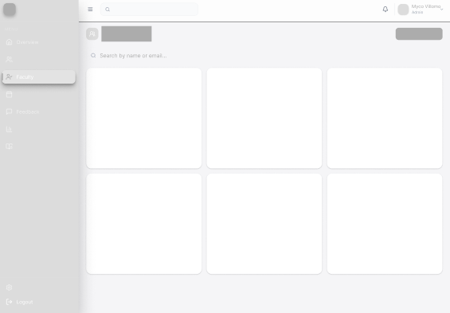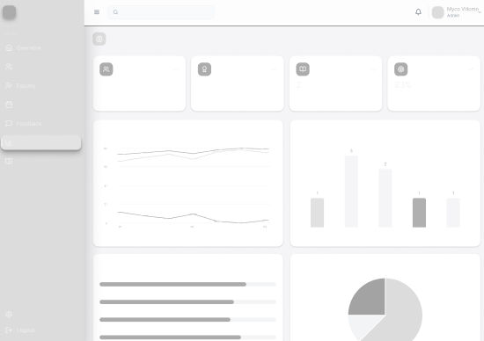
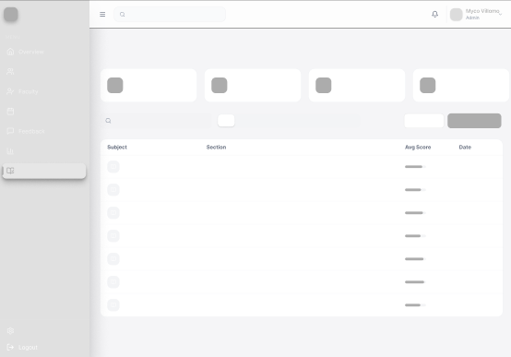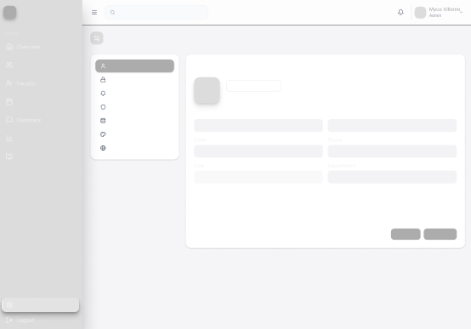
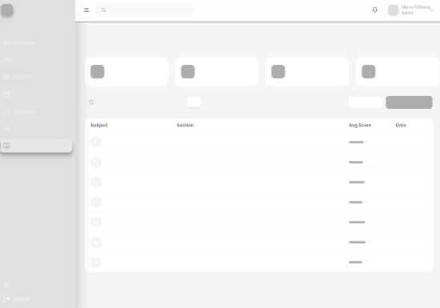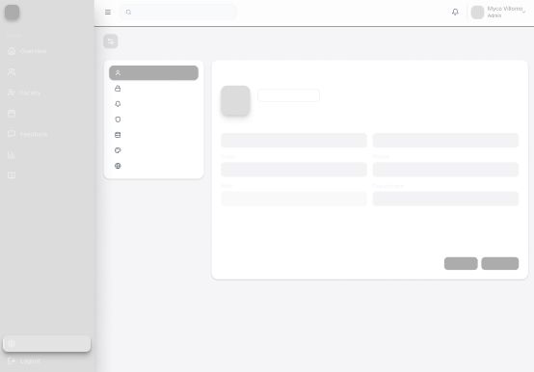
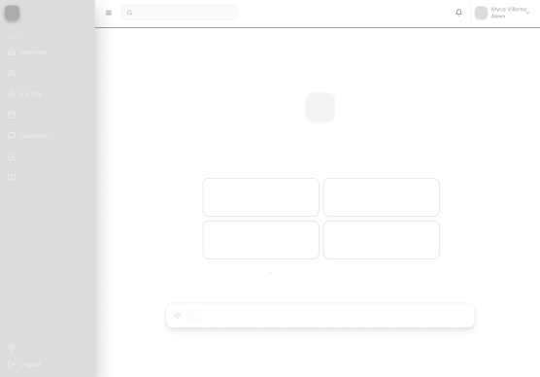

MOCKUPS
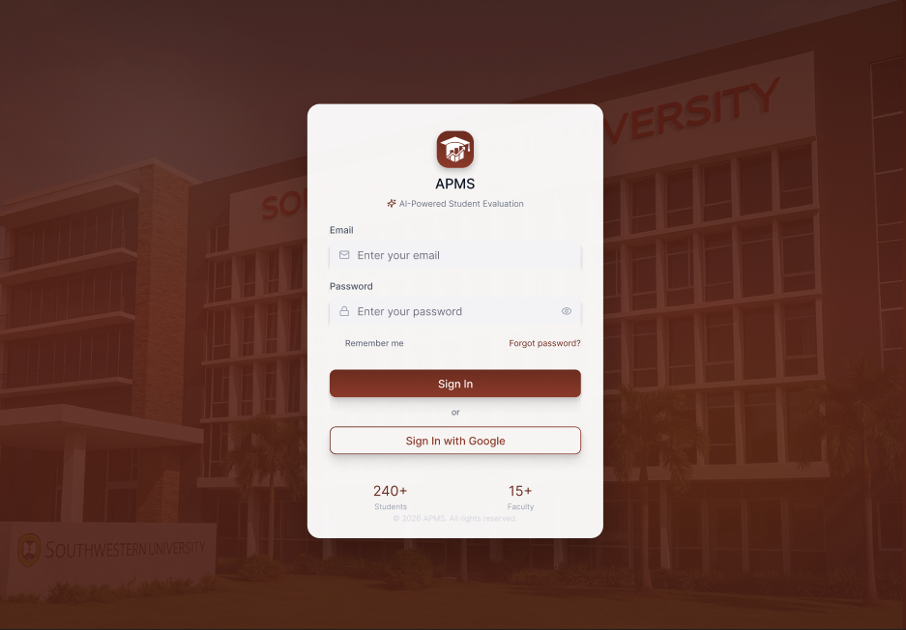

LOGIN PAGE
The figure above illustrates the login page of the AI-Based Student Performance Evaluation and Monitoring System. This page serves as the main user portal of the system and facilitates a secure and seamless login experience using either combination of an email address (a PHINMAEd email address for academic admin or faculty accounts), a strong password, and a six-digit MFA code sent to their email address, or they may opt to utilize the Sign In with Google option for faster and more seamless logins. Upon successful authentication, the user shall automatically be redirected to the dashboard that is most appropriate to their user role. This page also allows the storage of login credentials within the user’s device and an option to request for password recovery.
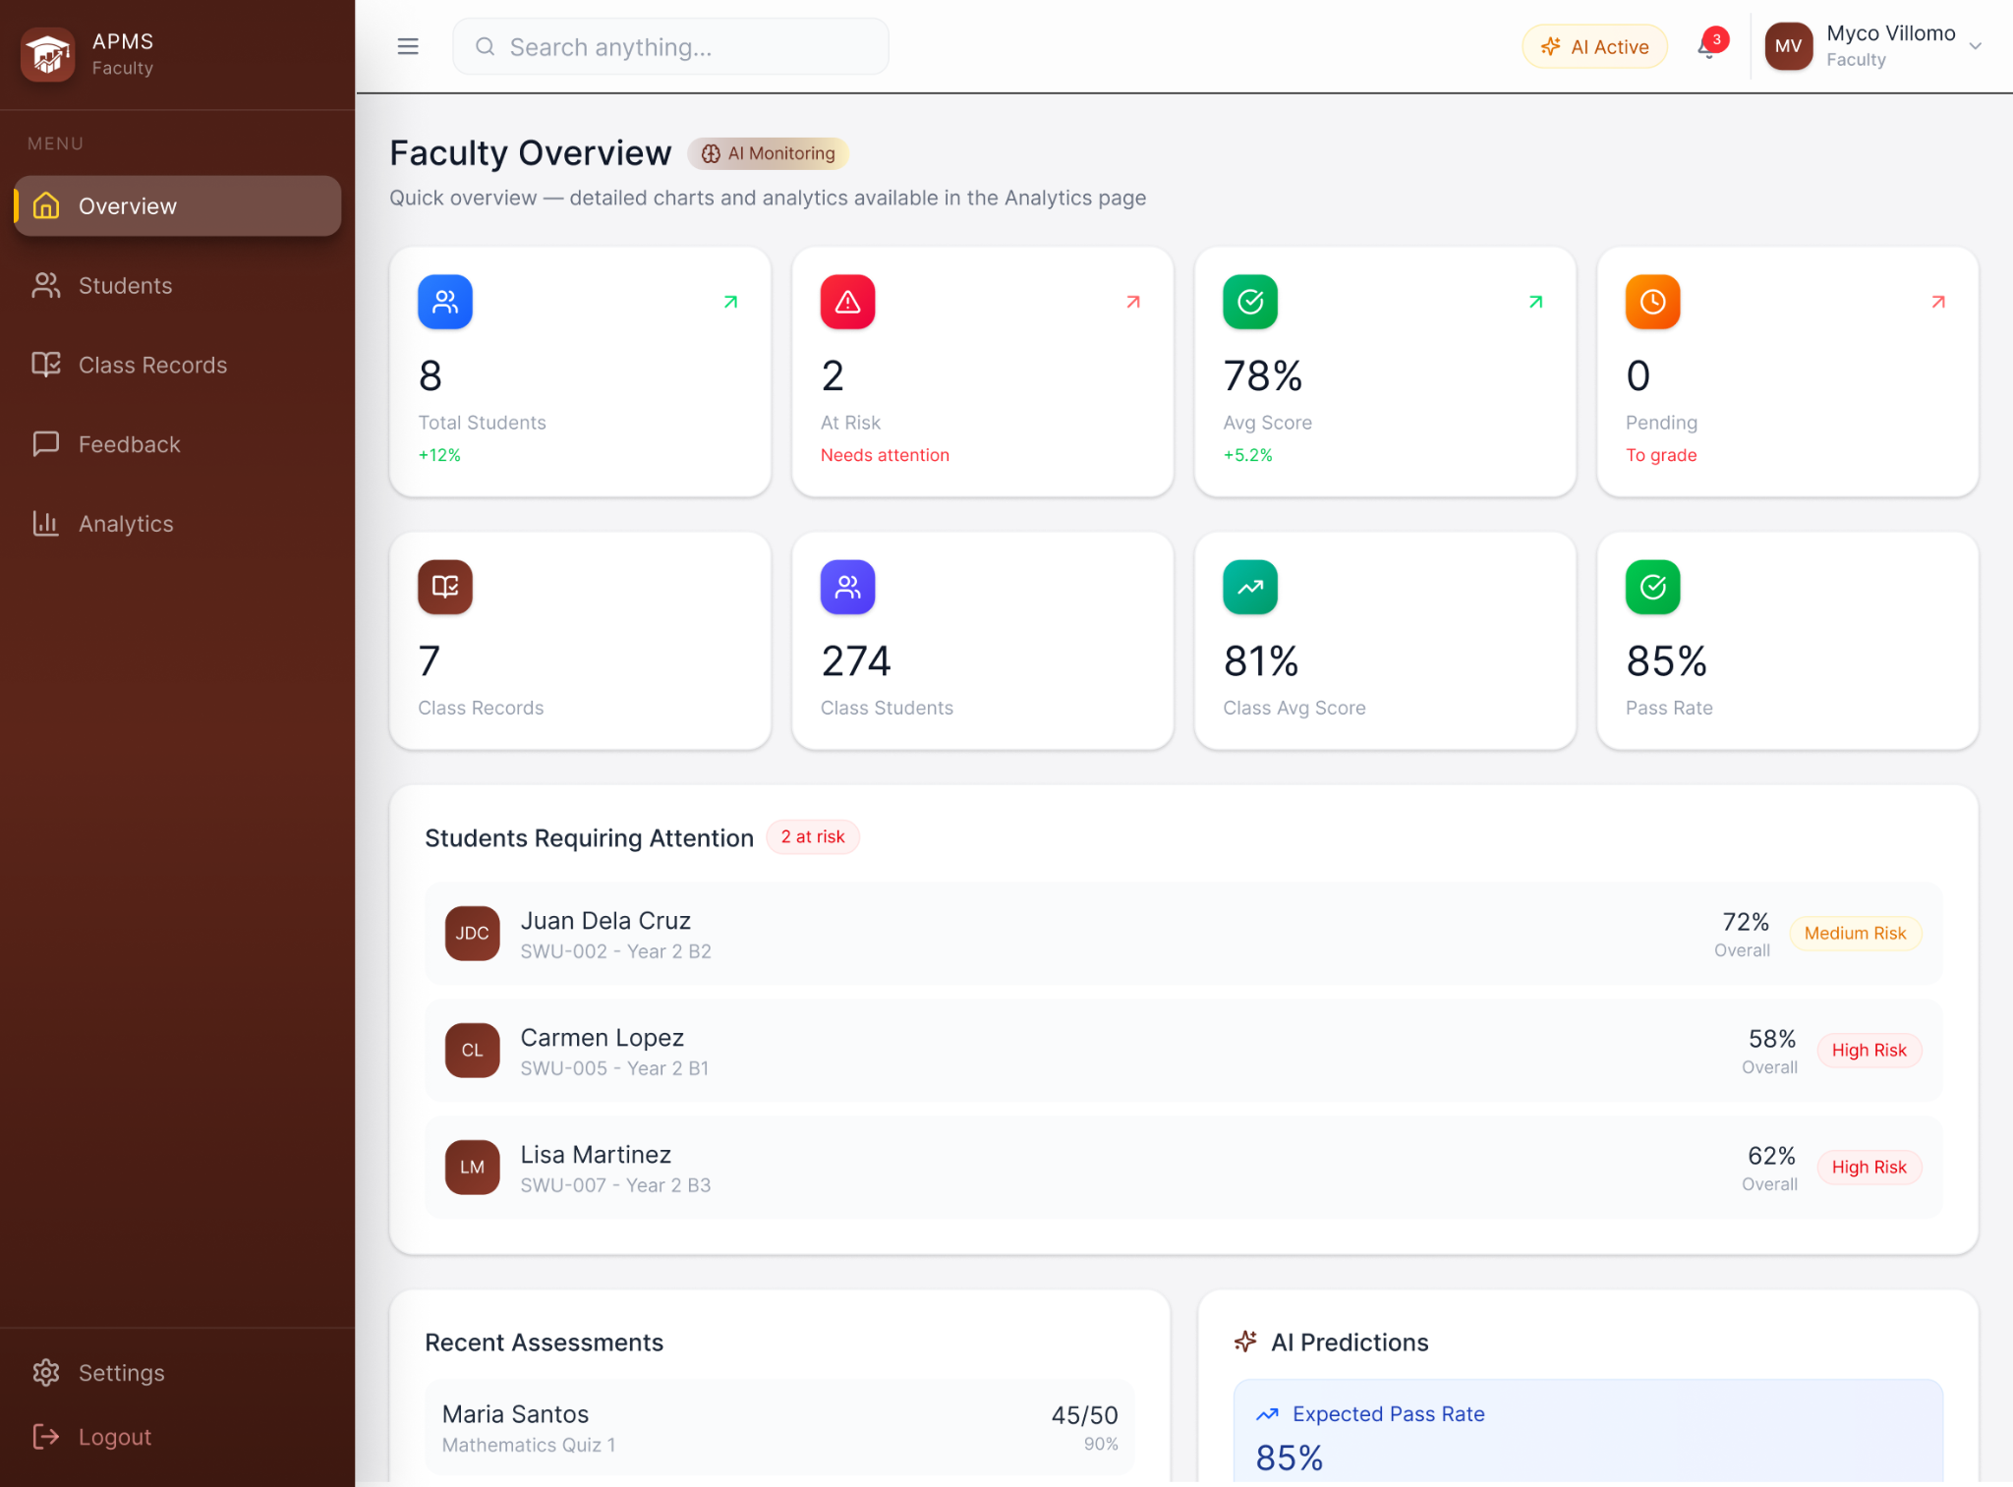
FACULTY - OVERVIEW DASHBOARD
The figure above shows the Faculty Overview dashboard of the AI-Based Student Performance Evaluation and Monitoring System. This page provides faculty and administrators with a compact, card-based summary of key statistics and student performance indicators (e.g. the number of class records, at-risk students, average score and predicted passing rate across the user’s class records with week-to-week changes), followed by secondary statistics and other predictive indicators. The “Students Requiring Attention” panel lists prioritized students with percentage grades and grade risk labels to help faculty members quickly triage students that might need immediate support or intervention, while the “Recent Assessments” panel shows the latest scores across all of a faculty’s classes. A left-hand sidebar facilitates intuitive navigation to various other pages, while the top bar contains a search field for pages, class records, students and others, a notification button, and the faculty’s user profile. The layout uses rounded cards and color-coded badges (green/amber/red) for instant status recognition, and supports interactive actions such as drilling into specific student details, filtering, and exporting; it is designed for clarity, quick scanning, and an efficient workflow for managing student performance while displaying relevant information for monitoring student performance..
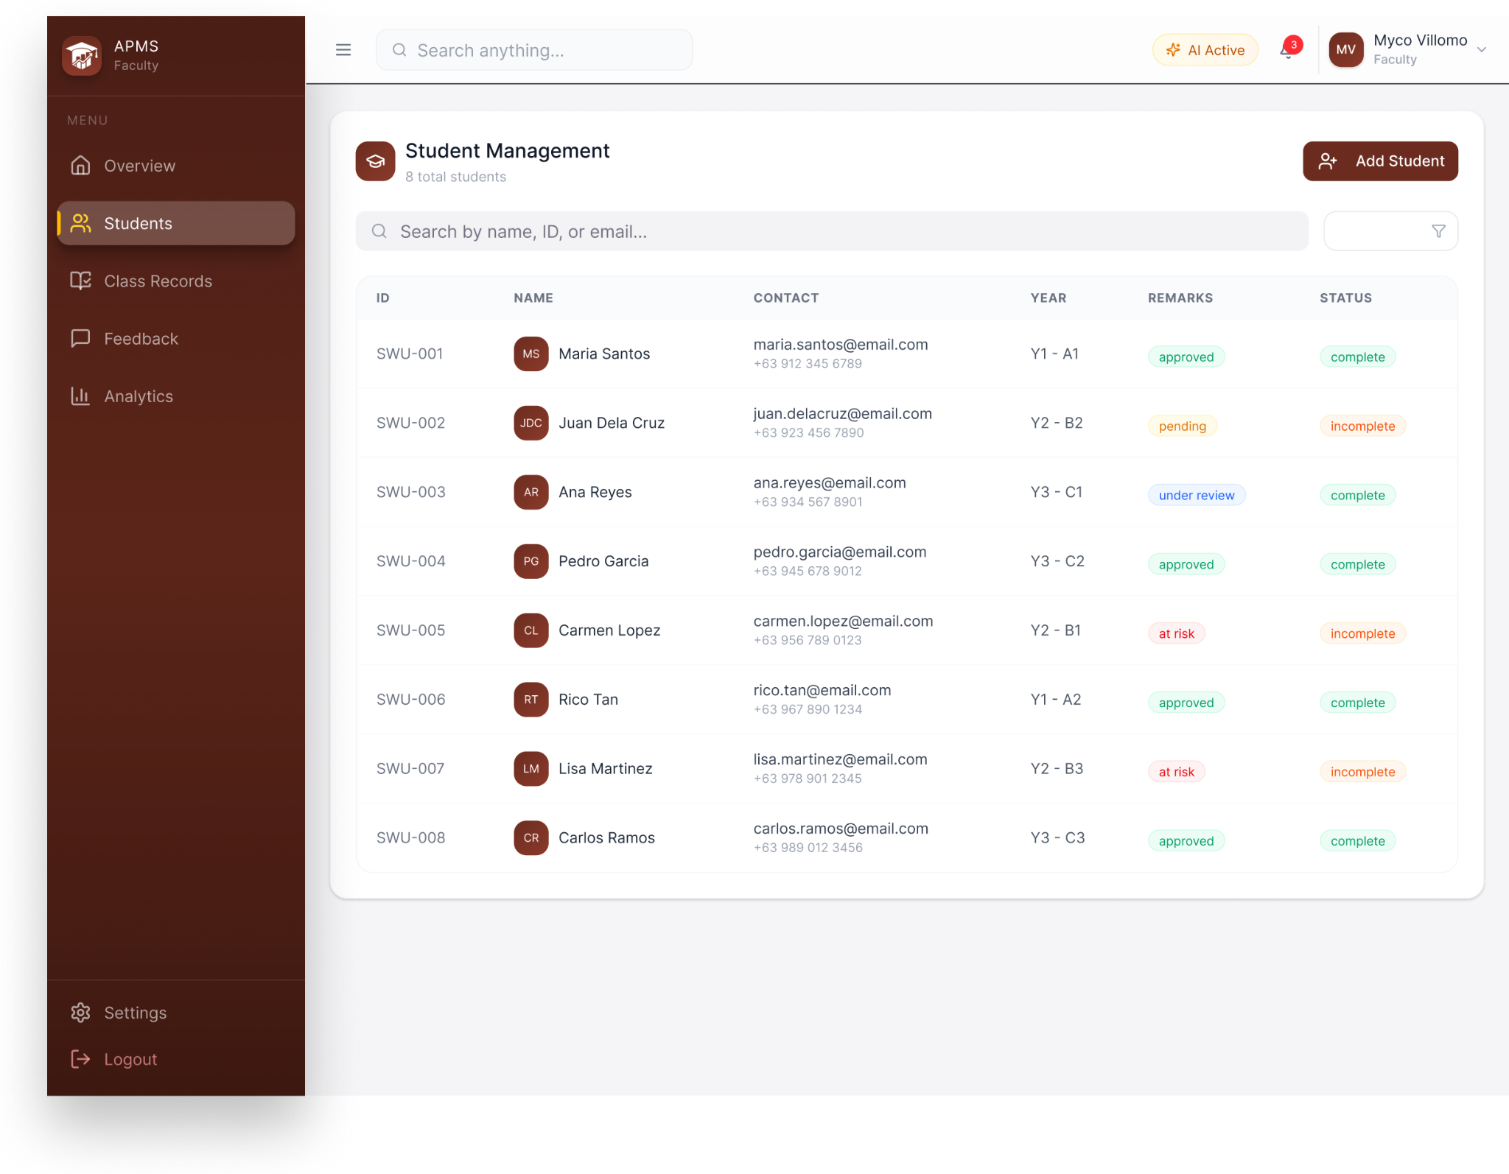
FACULTY - STUDENT MANAGEMENT PAGE
The figure above shows the Student Management page of the AI-Based Student Performance Evaluation and Monitoring System. This page provides a searchable, sortable roster view where faculty and administrators can quickly locate and manage individual student records. The main panel displays a clean table of students with columns for student ID, name, contact email, year, remarks, and status; each row includes a profile picture, quick color-coded status badges, and actionable controls such as selecting a record or adding a new student via the “Add Student” button. The interface supports searching by name, ID, or email, column sorting and filtering, inline status updates, and links to drill into detailed student profiles, assessment history, and student performance evaluation and prediction.
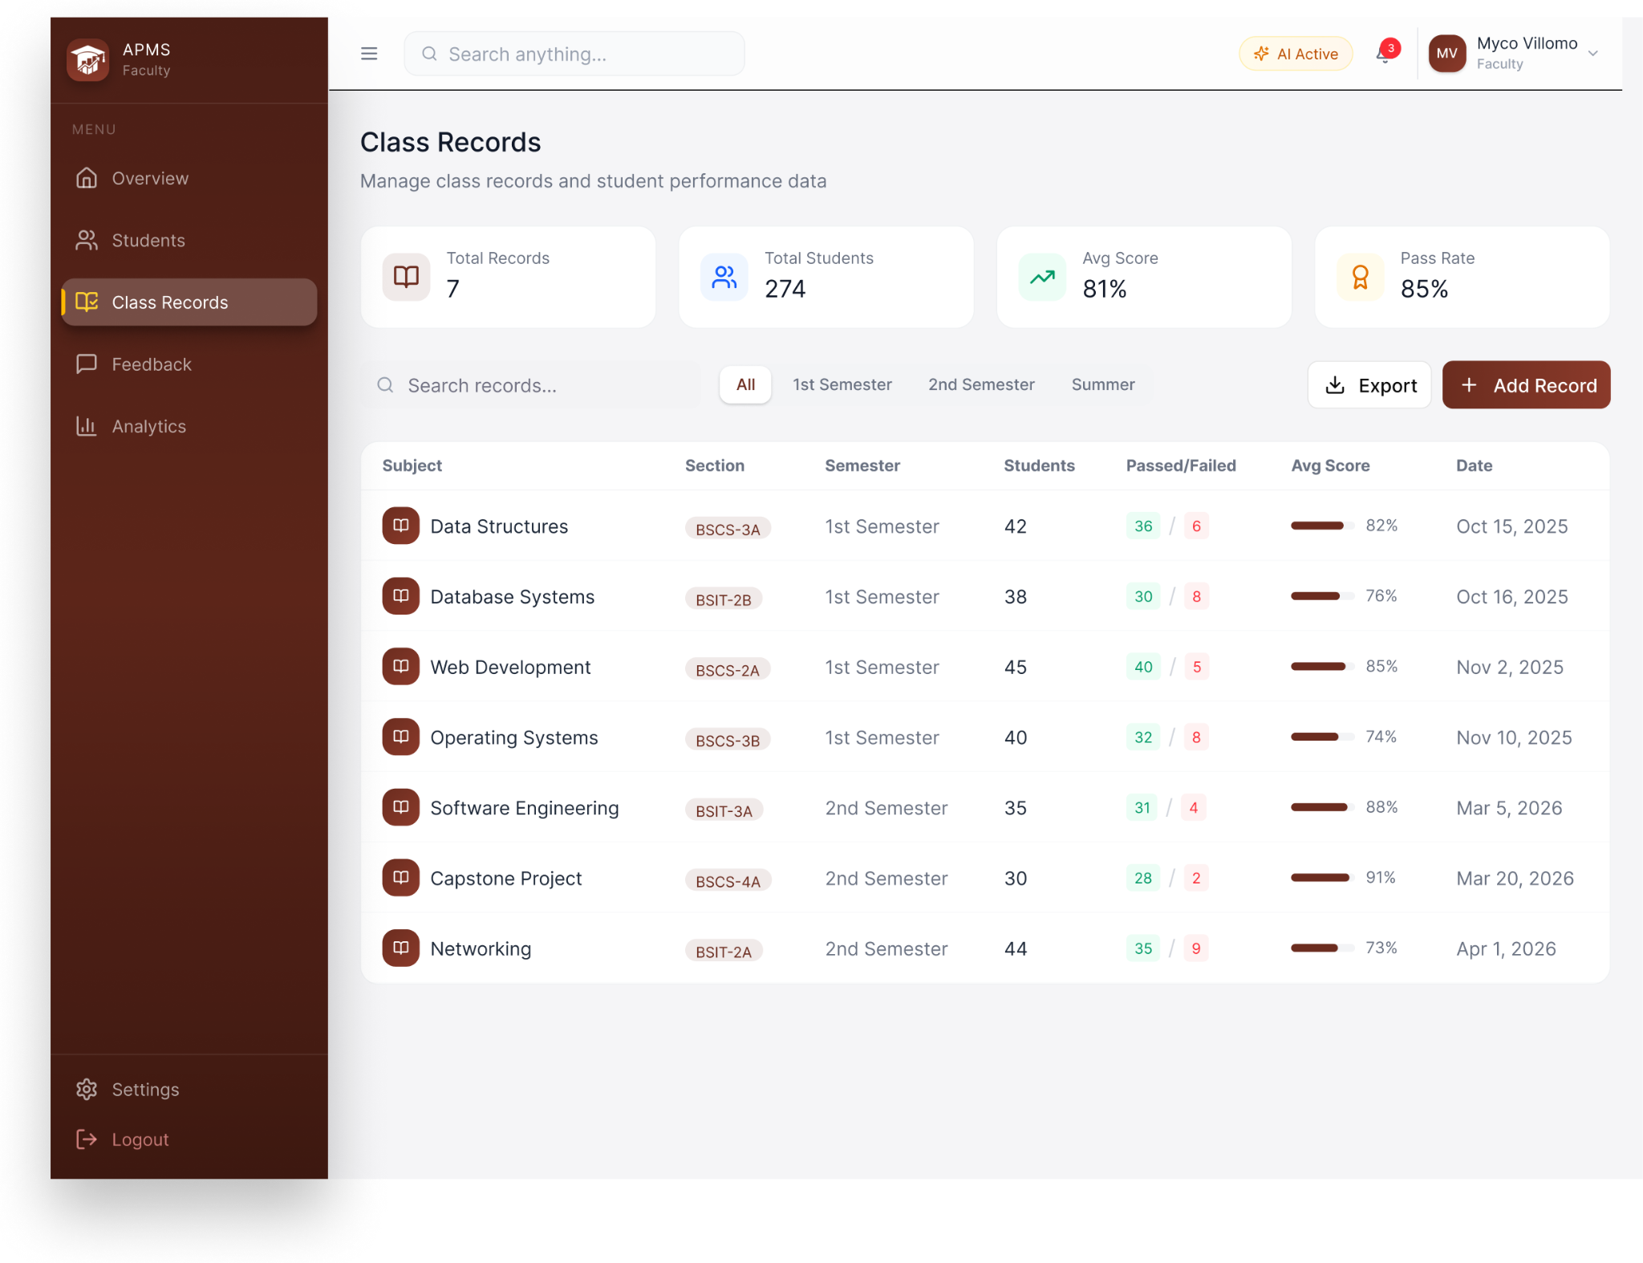
FACULTY - CLASS RECORDS PAGE
The figure above shows the Class Records page of the AI-Based Student Performance Evaluation and Monitoring System, a management interface where faculty members and administrators can view and act on class-level records and aggregated student performance data. The page header shows key student performance indicator cards (e.g. average score, predicted passing rate), with controls for searching, semester selection filters, exporting, and adding new records. The page lists class records with columns for subject, section, semester, number of students, pass/fail counts, average score, and date updated; each row includes a subject avatar and color‑coded progress bars or status badges for quick interpretation. The layout supports sorting, filtering, and selecting records to drill into detailed class lists, assessment breakdowns, version history, and export options.
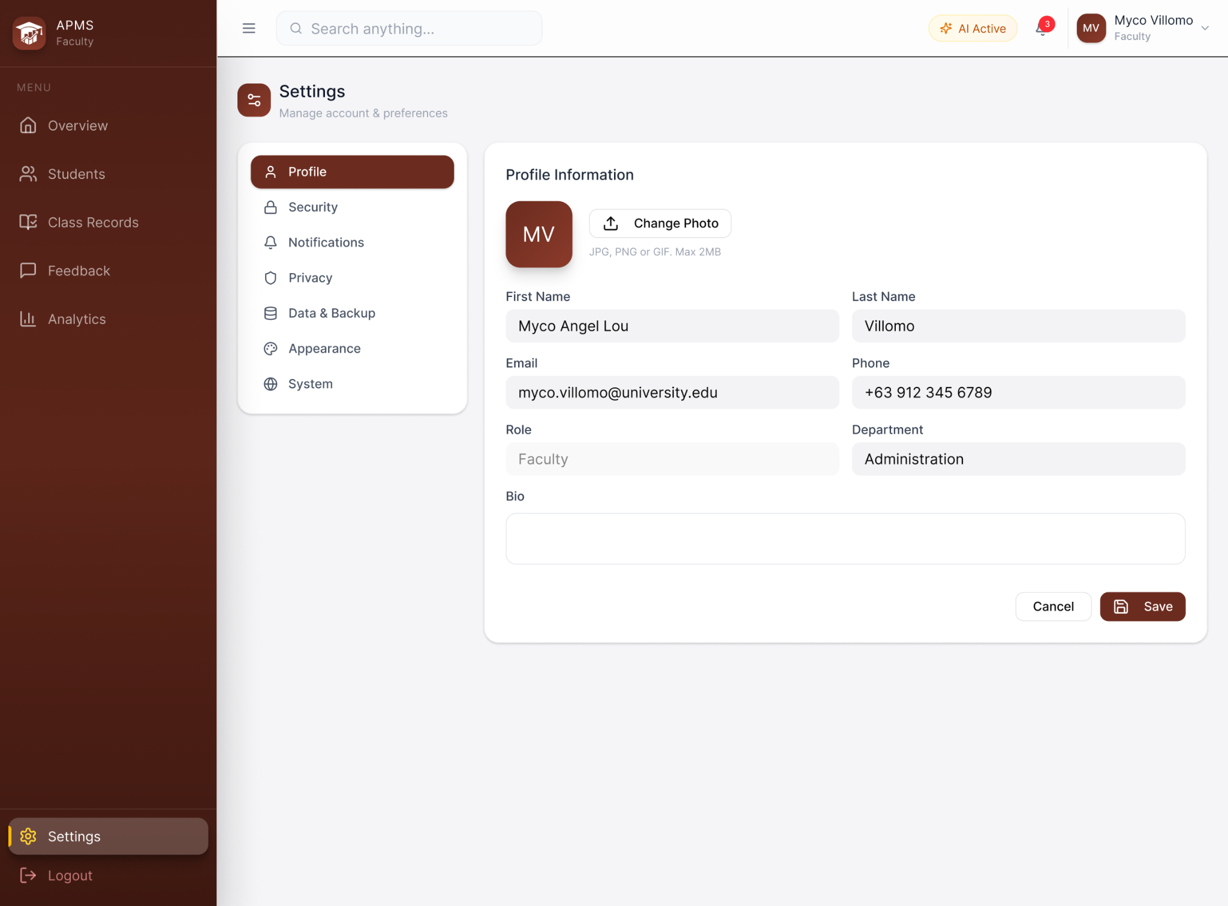
FACULTY - SETTINGS PAGE
The figure above shows the Settings page of the AI-Based Student Performance Evaluation and Monitoring System, more specifically the Profile Settings tab. This page provides a focused, role-appropriate area for managing a faculty’s information and preferences, account security, notifications, and data relevant to their instructional duties. It includes Profile Settings for editing a faculty’s profile information, Security Settings for changing passwords or configuring Multi-Factor Authentication, Notifications for choosing notification channels (e.g. assessments, at-risk alerts, feedback), Privacy Settings for visibility of personal and student-facing data, and Data & Backup Settings to request backup restorations. The interface emphasizes clear form layouts, visible input validation, and confirmation dialogs for sensitive changes.
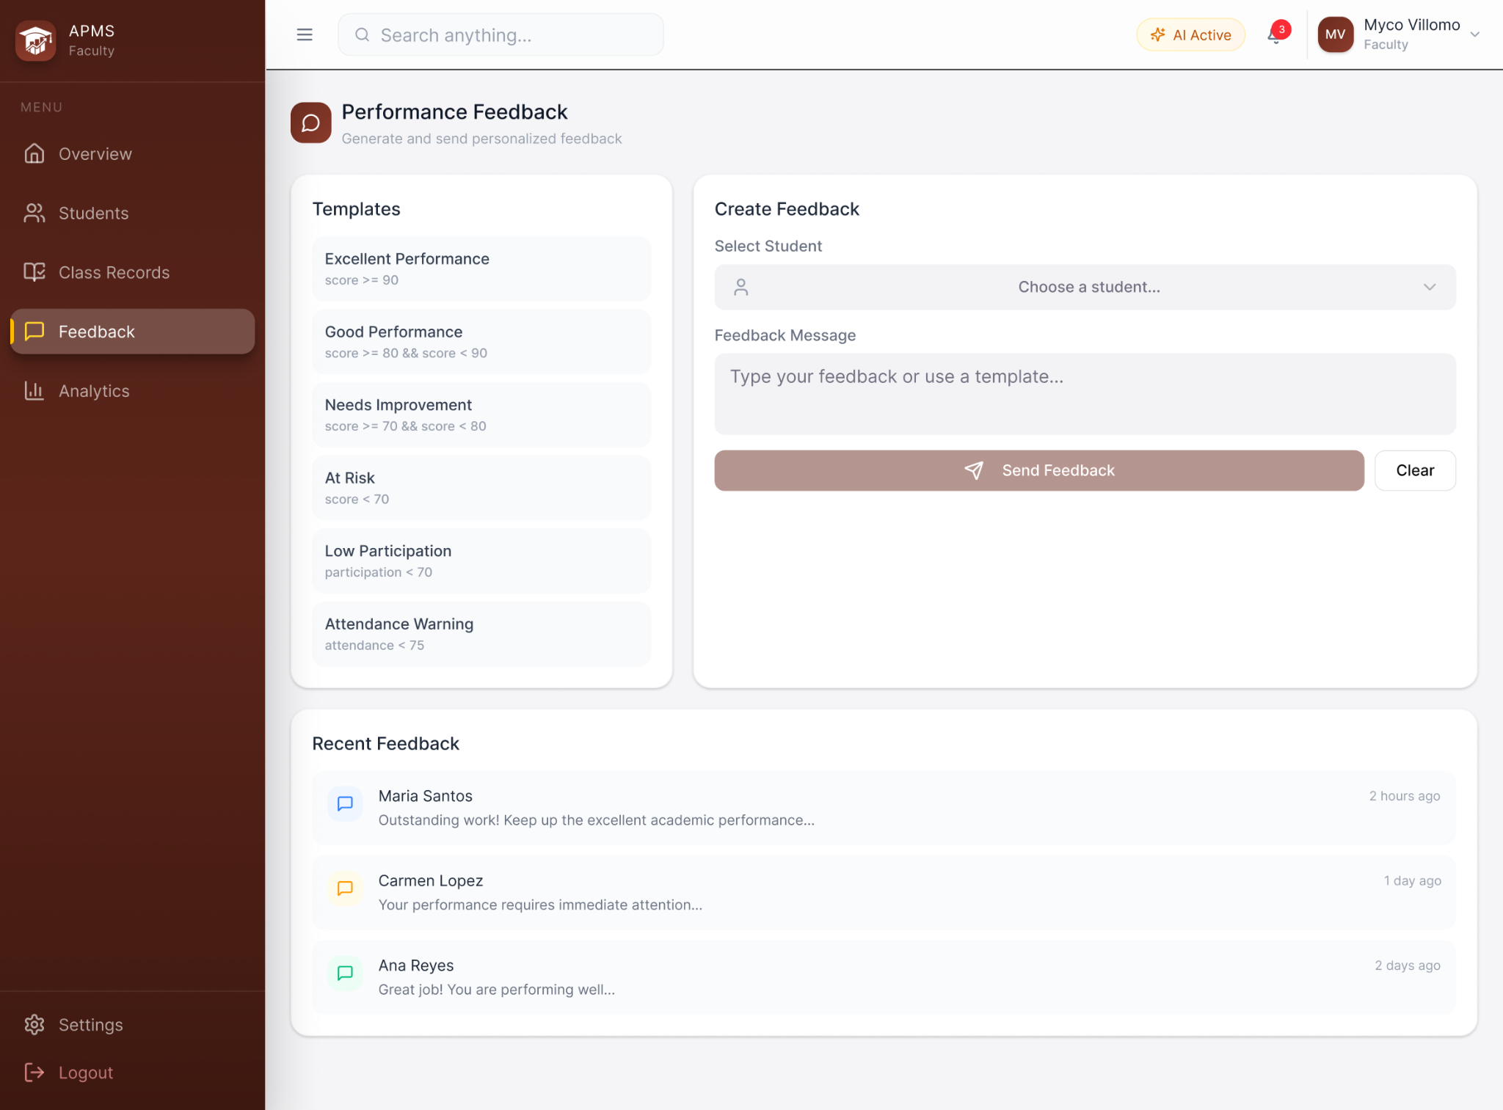
FACULTY - PERFORMANCE FEEDBACK PAGE
The figure above shows the Performance Feedback page of the AI-Based Student Performance Evaluation and Monitoring System. This page allows faculty to generate, manage, and send personalized feedback to students. The left column lists reusable feedback templates (e.g., Excellent, At-Risk, Attendance Warning) for quick selection, while the main panel lets faculty to select students, compose or edit feedback using a template or free text and send via email. A Recent Feedback feed at the bottom displays previously sent feedback messages. The page integrates with class records and assessment results so faculty can reference user-specified performance evaluation criteria while composing feedback, and includes controls for previewing messages and audit logging of sent feedback.
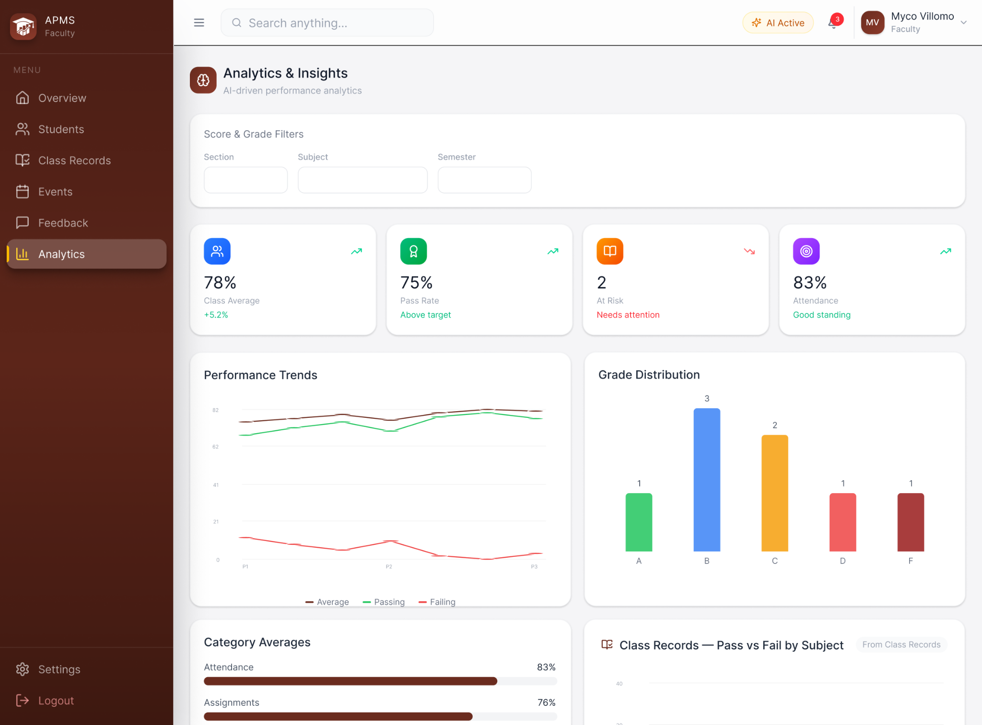
FACULTY - PERFORMANCE FEEDBACK PAGE
The figure above illustrates the Analytics & Insights page of the AI-Based Student Performance Evaluation and Monitoring System. This page provides a consolidated overview of class and student performance using a combination of summary cards, charts, and filtered data panels to support quick interpretation and action. Faculty members may apply section, subject, date, and score filters as well as search for particular students to refine the displayed metrics and focus on specific cohorts. The page shows cards and visualizations of various metrics such as student performance trends across various categories, passing rates, grade distributions, number of recent absences, and others, to give faculty members immediate class performance insights. This page supports core monitoring workflows such as viewing and filtering class records, viewing latest assessment results, visualizing at-risk cohorts flagged by prediction or evaluation modules, and exporting summarized data for reporting or backup.
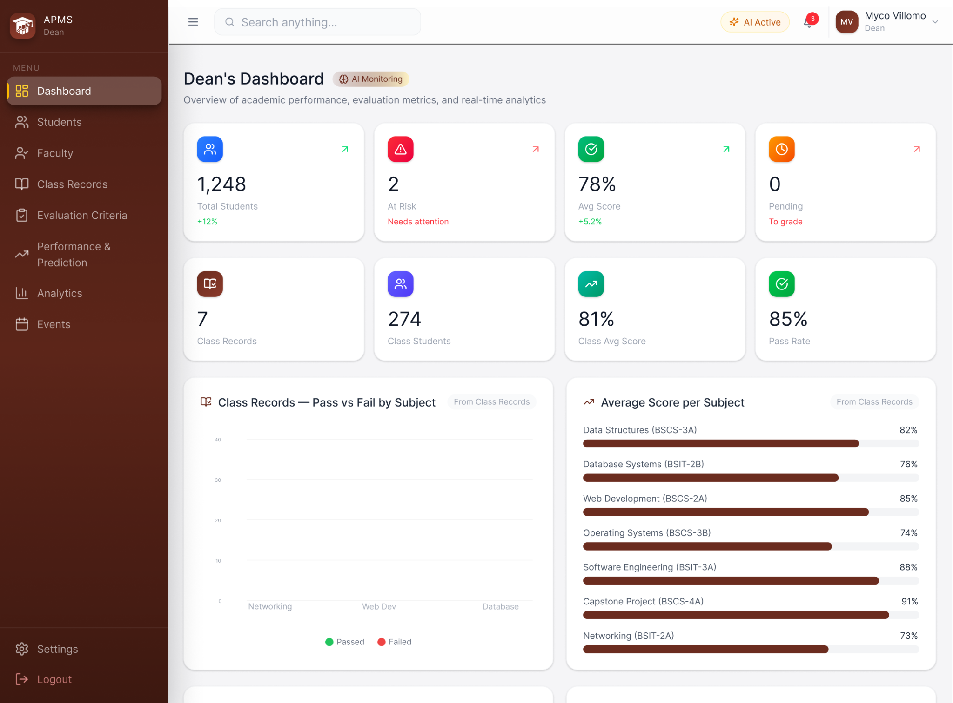
ACADEMIC ADMIN - OVERVIEW DASHBOARD
The figure above illustrates the Academic Admin Overview dashboard of the AI-Based Student Performance Evaluation and Monitoring System. This page provides a high-level executive summary of academic metrics and operational alerts tailored for administrative-level oversight. Key student performance indicators such as total number of enrolled students and class records, the overall pass rate provide a concise program-wide view of student performance, while visual panels include a Pass vs Fail by Subject chart for quick identification of subjects with low success rates and an Average Score per Subject bar chart that ranks subjects by mean performance to help prioritize interventions and resource allocation. The layout supports core academic administration tasks such as creating, importing, viewing and exporting class records templates, filtering and sorting class records by performance metrics, and quickly locating at-risk subjects or cohorts for follow-up actions.
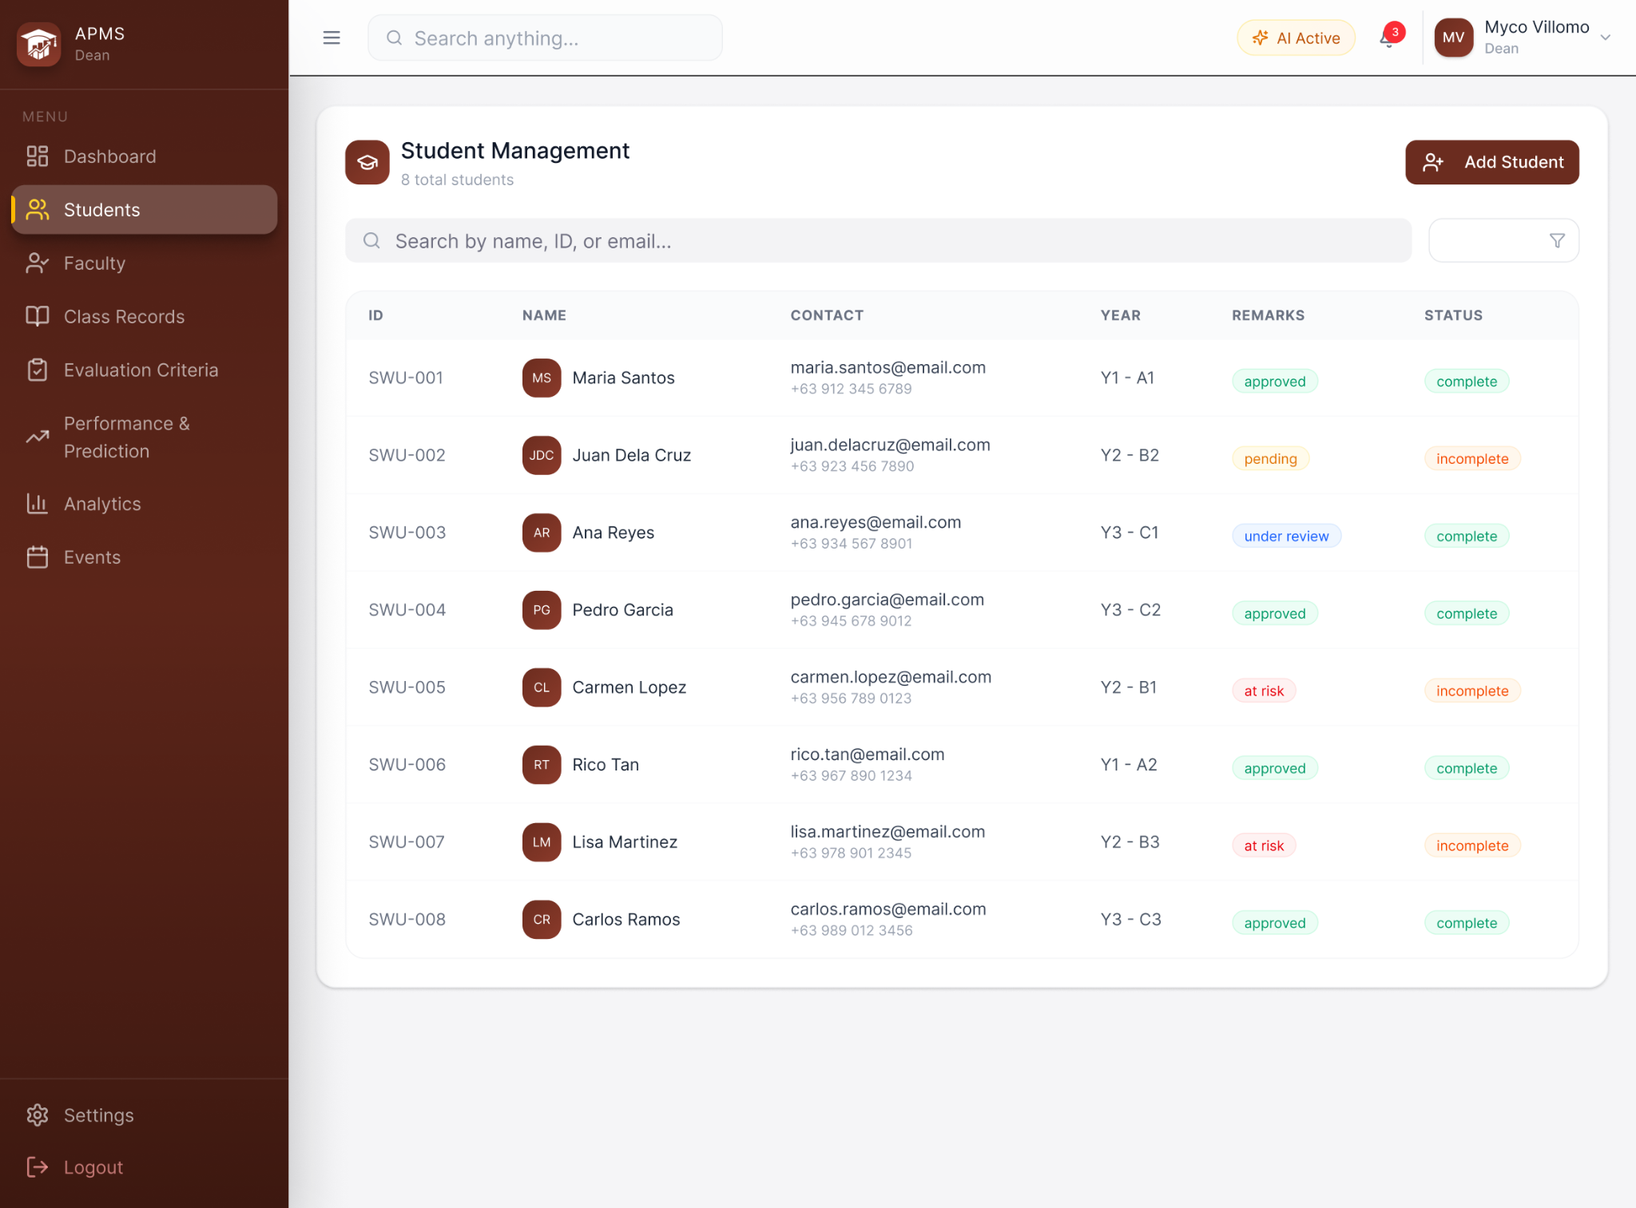
ACADEMIC ADMIN - STUDENT MANAGEMENT PAGE
The figure above illustrates the Student Management page of the AI-Based Student Performance Evaluation and Monitoring System. This page centralizes the student information used for student record maintenance. Academic administrators can search by name, student ID, or email email address, and add new student records via the Add Student button, which allows adding students manually, or by using a CSV or text file that contains a class list. The Student Management page lists each student’s ID, name, contact email, year and section, remarks, and current status, while row-level actions enable the viewing or editing of an individual student’s profile information and linked class records, and monitoring their academic performance.
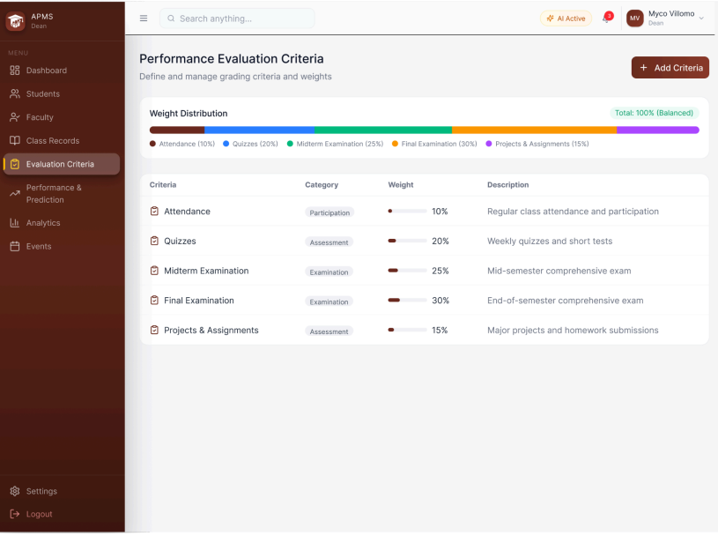
ACADEMIC ADMIN - PERFORMANCE EVALUATION CRITERIA PAGE
The figure above illustrates the Performance Evaluation Criteria page of the AI-Based Student Performance Evaluation and Monitoring System. This page enables academic administrators to define, review, and manage the weighted grading criteria used for student performance evaluation across various classes and programs. A horizontal weight-distribution bar at the top visually summarizes how the total grade is allocated across categories (e.g., attendance, quizzes, midterm, final, projects) so users can quickly verify that weights sum to 100% of each semester. Categories such as periods (e.g. P1, P2, P3), period components (e.g. CS, PE), and assessment-level categories (e.g. Short Quizzes, Hands-On Exams, CFE, etc.) can be customized within the page. The main panel lists each criterion with its category, assigned weight percentage, and a brief description, allowing straightforward editing or reordering of criteria. Academic administrators may add new criteria, edit existing weights and descriptions, and persist changes that feed into automated grade calculations and downstream modules such as performance evaluation, prediction, and feedback generation.

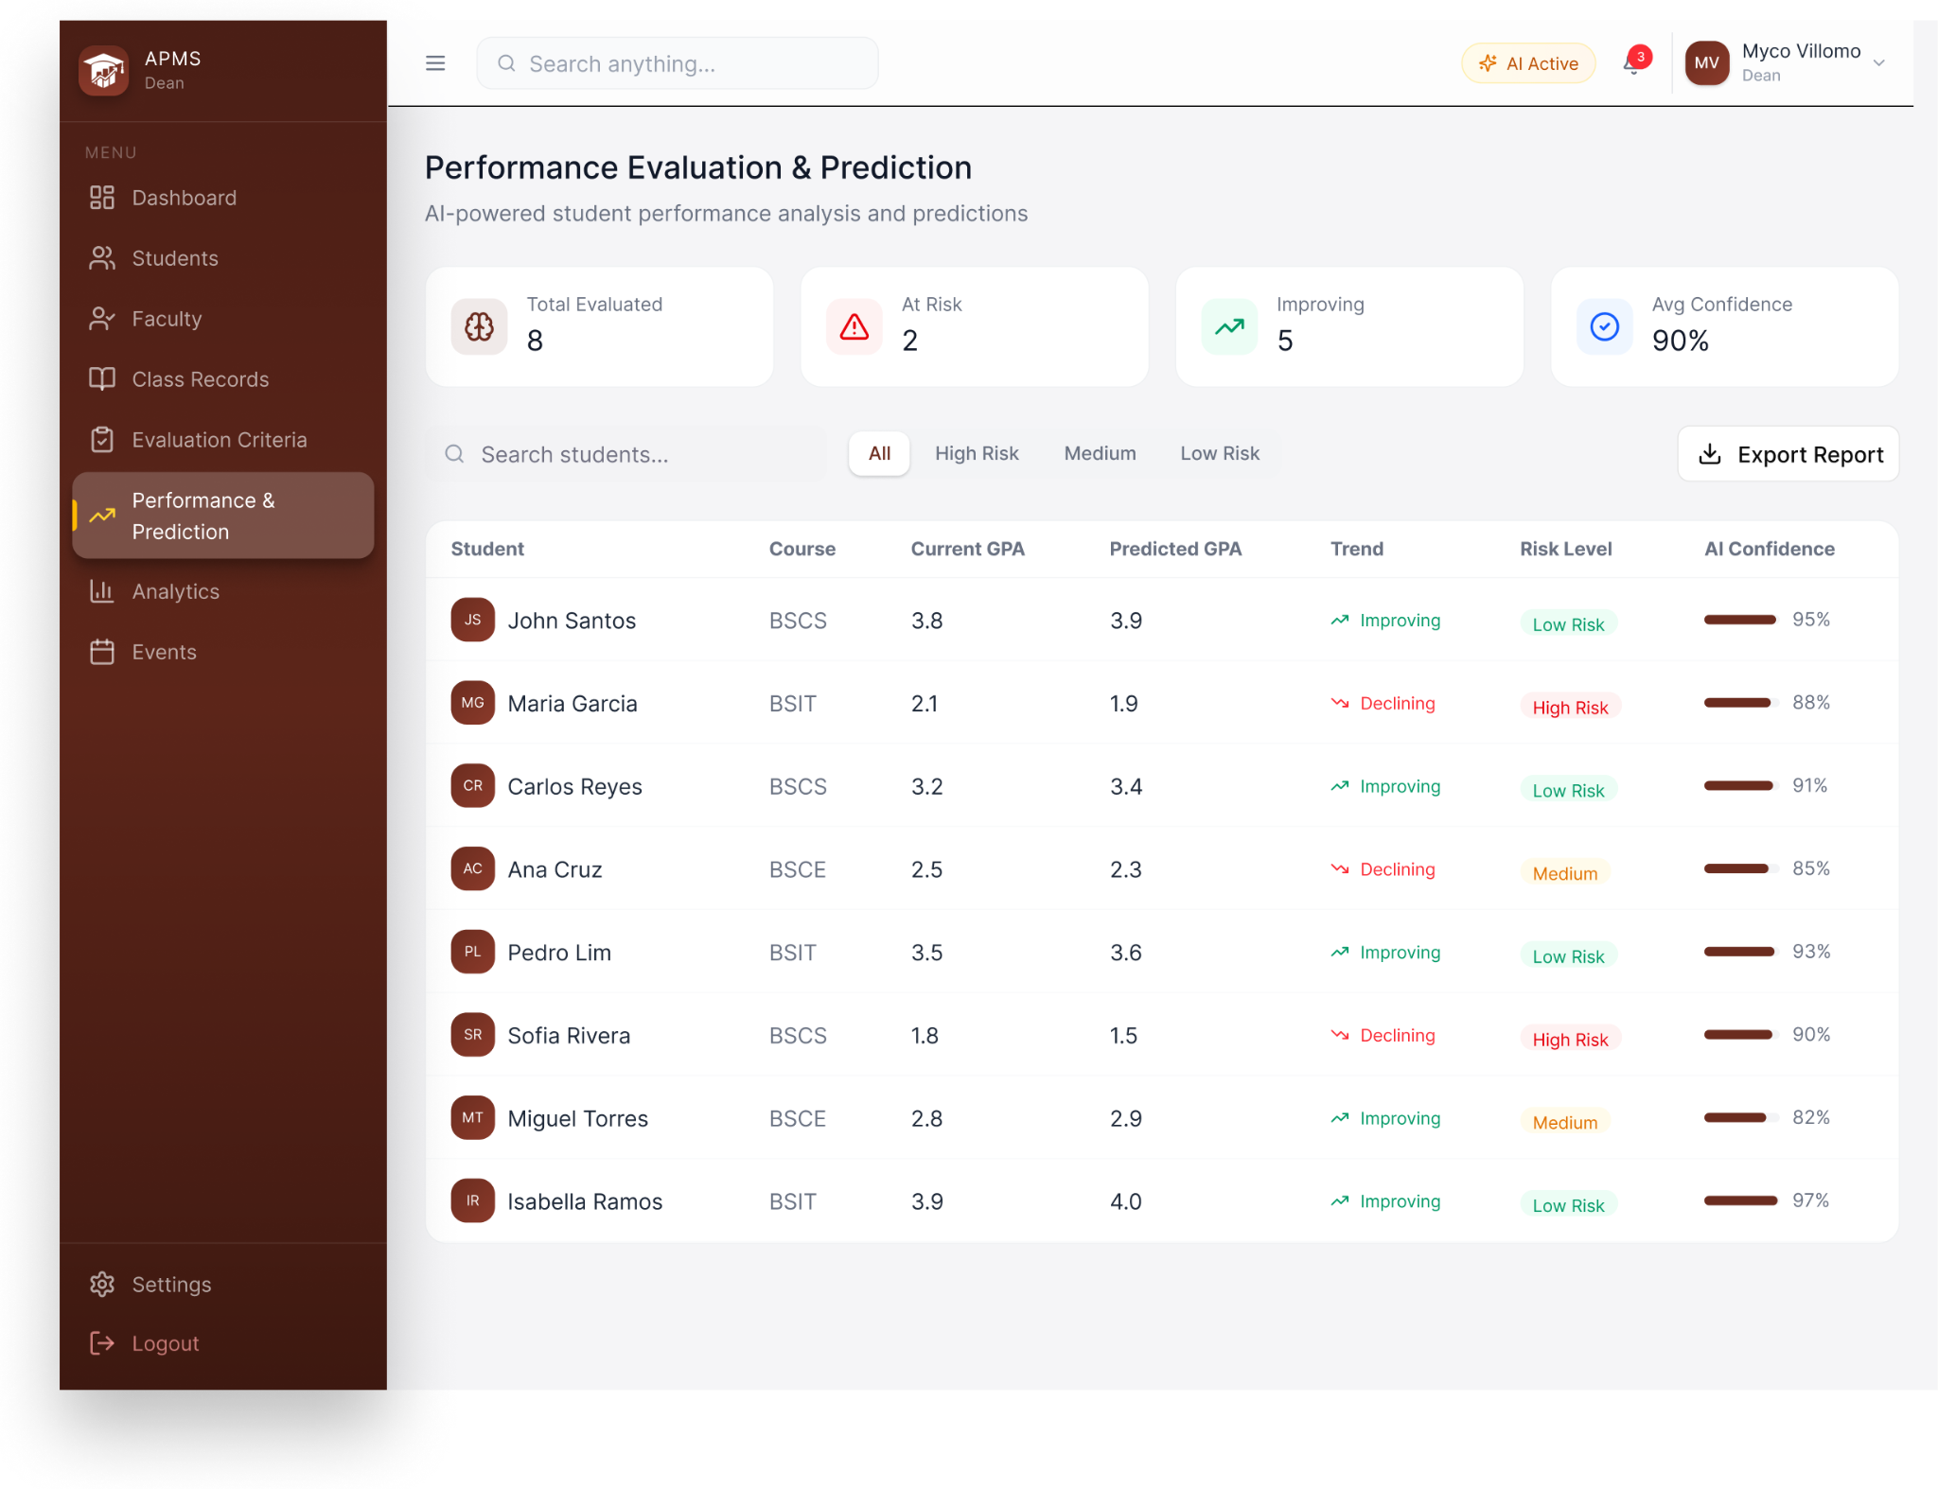
ACADEMIC ADMIN - PERFORMANCE EVALUATION AND PREDICTION PAGE
The figure above illustrates the Performance Evaluation & Prediction page of the AI-Based Student Performance Evaluation and Monitoring System. This page integrates artificial intelligence in providing student performance evaluation and prediction to assess current student performance and predict future outcomes, assisting faculty members in prioritizing early interventions. The top row displays aggregate indicators such as total evaluated students, number of at-risk students, number of improving classes, and average AI model confidence. The main panel shows a searchable and filterable table that lists individual students with columns for degree program, current point grades, predicted point grades, overall performance trends (e.g., improving or declining), risk level (e.g., high, medium, low), and AI confidence score. The inline trend labels and risk badges enables easy identification of students needing immediate review or targeted feedback, and an Export Report action enables batch reporting to a PDF. This page supports the application of various performance prediction criteria, such as min (predicted performance with minimum possible grade), max (predicted performance with max possible grade), min-pass (minimum predicted performance needed to pass a specific course), and stable (predicted performance aligned with current performance trends), the viewing and filtering class records by prediction and evaluation results, and generating personalized feedback or alerts for follow-up.

REFERENCES
Ab Rahman, N. F., Wang, S. L., Ng, T. F., & Ghoneim, A. S. (2024). Artificial intelligence in education: A systematic review of machine learning for predicting student performance. ARASET: Journal of Artificial Intelligence Research and Applications in Science and Engineering Technology, 54(1), 198–221. doi:10.37934/ARASET.54.1.198221.
Albreiki, B., Zaki, N., & Alashwal, H. (2021). A systematic literature review of student performance prediction using machine learning techniques. Education Sciences, 11(9), 552. doi:10.3390/educsci11090552.
Alshabandar, R., Hussain, A. J., Liatsis, P., & Keight, R. (2022). Student performance prediction using machine learning techniques. 2022 International Conference on Intelligent Systems and Computer Vision (ISCV). IEEE. doi:10.1109/ACCESS.2022.3188767.
Bhangu, S., Provost, F., & Caduff, C. (2023). Introduction to qualitative research methods - Part I. Perspectives in clinical research, 14(1), 39–42. doi:10.4103/picr.picr_253_22
Brailas, A., Tragou, E., & Papachristopoulos, K. (2023). Introduction to qualitative data analysis and coding with QualCoder. American Journal of Qualitative Research, 7(3), 19-31. doi:10.29333/ajqr/13230.
Canalita, E., & Jugar, R. (2025). Development and evaluation of a collaborative lesson planning model for science teacher internships. International Journal of Learning, Teaching and Educational Research, 24(6), 588–608. doi:10.26803/ijlter.24.6.27.
Cobern, W., & Adams, B. (2020). When interviewing: how many is enough? International Journal of Assessment Tools in Education, 7(1), 73-79. doi:10.21449/ijate.693217.
Croucher, J. S. (2004). An upper bound on the value of the standard deviation. Teaching Statistics, 26(2), 54–55. doi:10.1111/j.1467-9639.2004.00157.x.
Demartini, C. G., Sciascia, L., Bosso, A., & Manuri, F. (2024). Artificial intelligence bringing improvements to adaptive learning in education: A case study. Sustainability, 16(3), 1347. doi:10.3390/su16031347.
Du, X., Yang, J., Hung, J. L., & Shelton, B. (2020). Educational data mining: A systematic review of research and emerging trends. Information Discovery and Delivery, 48(4), 225–236. doi:10.1108/IDD-09-2019-0070.
Etikan, I., Musa, S. A., & Alkassim, R. S. (2015). Comparison of Convenience Sampling and Purposive Sampling. American Journal of Theoretical and Applied Statistics, 5(1), 1-4. doi:10.11648/j.ajtas.20160501.11.
Ifenthaler, D., & Yau, J. Y.-K. (2020). Utilising learning analytics to support study success in higher education: A systematic review. Educational Technology Research and Development, 68, 1961–1990. doi:10.1007/s11423-020-09788-z.
International Association of Universities. (2026). About - WHED - IAU’s world higher education database. World Higher Education Database. https://www.whed.net/About.html.
Merino-Campos, C. (2025). The impact of artificial intelligence on personalized learning in higher education: A systematic review. Trends in Higher Education, 4(2), 17. doi:10.3390/higheredu4020017.
Mornie, M. N., Jali, N., Shiang, C. W., Mit, E., Saee, S., Jali, S. K., & Greer, D. (2026). Visualisation of user stories to UML use case diagram. Journal of Advanced Research in Applied Sciences and Engineering Technology, 63(3), 68-80. doi:10.37934/araset.63.3.6880.
Nahar, K., Shova, B. I., Ria, T., Rashid, H. B., & Islam, A. H. M. S. (2021). Mining educational data to predict students performance: A comparative study of data mining techniques. Education and Information Technologies, 26, 6051–6067. doi:10.1007/s10639-021-10575-3.
Namoun, A., & Alshanqiti, A. (2021). Predicting student performance using data mining and learning analytics techniques: A systematic literature review. Applied Sciences, 11(1), 237. doi:10.3390/app11010237.
Manu, E., & Akotia, J. (Eds.). (2021). Secondary research methods in the built environment. pp. 1-15. Routledge. doi:10.1201/9781003000532.
Napolitano, E. V., Masciari, E., & Ordonez, C. (2024). Integrating flow and structure in diagrams for data science. 2024 IEEE International Conference on Big Data. 5769-5774. doi:10.1109/BigData62323.2024.10826098.
Nurkholis, N., Wilarso, Sukamto, P., Anas, S. M., Jamaludin, S., & Umar, T. A. (2024). Digital survey for customer satisfaction of regional drinking water companies (PDAM) using the mWater application and the Slovin formula method. BIO Web Conf., 144(03006). doi:10.1051/bioconf/202414403006.
Rahman, M. M. (2023). Sample size determination for survey research and non-probability sampling techniques: A review and set of recommendations. Journal of Entrepreneurship, Business and Economics, 11(1), 42-62.
Salisi, G., & Balahadia, F. (2025). EduComply: a progress tracking system for compliance in teaching-learning deliverables using decision support system. International Journal of Science, Technology, Engineering & Mathematics, 5(3), 40–78. doi:10.53378/ijstem.353240.
Slater, P., & Hasson, F. (2025). Quantitative research designs, hierarchy of evidence and validity. Journal of psychiatric and mental health nursing, 32(3), 656–660. doi:10.1111/jpm.13135
Tetteh, S. G. (2024). Empirical study of Agile software development methodologies: a comparative analysis. Asian Journal of Research in Computer Science, 17(5), 30–42. doi:10.9734/ajrcos/2024/v17i5436.
Wu, C. (2022). Statistical inference with non-probability survey samples. Survey Methodology, 48(2), 283-311. Retrieved from https://www.math.uwaterloo.ca/~cb
wu/paper/22-Wu-SMJ.pdf.
Yuskovych-Zhukovska, V., Poplavska, T., Diachenko, O., Mishenina, T., Topolnyk, Y., & Gurevych, R. (2022). Application of artificial intelligence in education: Problems and opportunities for sustainable development. BRAIN: Broad Research in Artificial Intelligence and Neuroscience, 13(1Sup1), 339–356. doi:10.18662/brain.
Zhang, L. (2019). On valid descriptive inference from non-probability sample. Statistical Theory and Related Fields, 3(2), 103–113. doi:10.1080/24754269.2019.1666241.

